SENIOR FIVE TERM 3
TOPIC 4: Respiration
Competency: The learner appreciates how living organisms generate cellular energy, by analysing respiratory processes and the chemical breakdown of food within cells, to make informed decisions that promote good health and wellbeing.
Contents
Respiration 2
Uses of ATP 2
Cell respiration 2
Adaptations of mitochondria 3
The break of glucose in respiration 3
Stages of glycolysis in the cytoplasm of the cell 4
Aerobic respiration 5
The Krebs cycle, tricarboxylic cycles or citric cycle 5
Electron transport in the stalked membrane of the mitochondria 7
How ATP production changes during various exercise intensities 7
Effect of cyanide on respiration 9
Anaerobic respiration 10
Differences in aerobic and anaerobic respiration 11
Alternative respiratory substances 11
Respiratory Quotients 11
Basal metabolic rate 13
Factors affecting the BMR 13
Revision Exercise 15

Respiration
This is the oxidation of organic substance to liberate energy in the body. Aerobic respiration requires oxygen whereas anaerobic respiration does not require oxygen.
Organic molecules (usually carbohydrate or fat) are broken down bond by bond, by a series of enzyme - controlled reactions. Each bond broken releases a small amount of energy converted to adenosine triphosphate (ATP). ATP is the immediate source of energy for cellular reactions.

Uses of ATP
- Provide energy to build up macromolecules such as proteins from amino acids, polysaccharides form monosaccharides and DNA synthesis.
- Provide energy for movement of materials such as active transport.
- Provides energy for secretion of materials.
- Provide energy for muscle contraction, spindle formation in cell division and ciliary action
- Provide energy for activation of molecules before they are used in the body.

Cell respiration
Cell respiration involves oxidation of a substrate to yield chemical energy (ATP). Organic compounds which are used as substrates in respiration are carbohydrates, fats and proteins.

Carbohydrates
These are usually the first choice of most cells. In fact, brain cells of mammals cannot use anything but glucose. Polysaccharides are hydrolyzed to monosaccharides before they enter the respiratory pathway i.e. starch in plant and glycogen in animals are first converted to glucose.

Fats/lipids
They form the “first” reserve and are mainly used when carbohydrate reserves have been exhausted. However, in skeleton muscle cells, if glucose and fatly acids are available, these cells respire the acids in preference to glucose.
Lipids are better energy source than carbohydrates because they have a higher proportion of hydrogen and an almost insignificant proportion of oxygen compared with carbohydrates. Thus a given mass of lipids yields more energy on oxidation than an equal mass of carbohydrate.

Proteins
Since proteins have other essential functions they are only used when all carbohydrate and fat reserves have been used up, as during prolonged starvation.

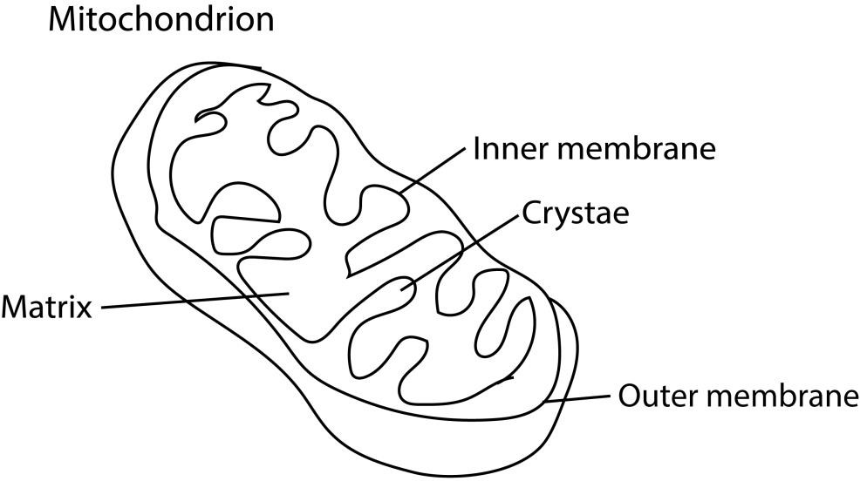
Function
Production of cellular energy, ATP

Adaptations of mitochondria
- Membranes are permeable to enable the mitochondrion acquire oxygen and metabolites and also to release carbon dioxide and its products.
- Has extensive folding of inner membrane to create a high surface area for enzymes that produce ATP.
- The inner membrane is highly impermeable to most ions and small molecules. This property is critical for maintaining the proton gradient needed for chemiosmosis and ATP synthesis
- The inter-membrane space is narrow, allowing protons pumped by the ETC to accumulate quickly and create a steep electrochemical gradient.
- have a small amount of mitochondrial DNA, allowing them to create mitochondrial proteins quicker than from nucleic genes.
- Have necessary enzymes for production of energy

The break of glucose in respiration
When glucose is the substrate of respiration, its oxidation can be divided into three phases, glycolysis, oxidative de-carboxylation (Krebs or citric acid cycle or TCA, tri-carboxylic acid cycle); oxidative phosphorylation. Glycolysis is common to anaerobic and aerobic respiration, but the other two phases only occur only in presence of oxygen.

Stages of glycolysis in the cytoplasm of the cell
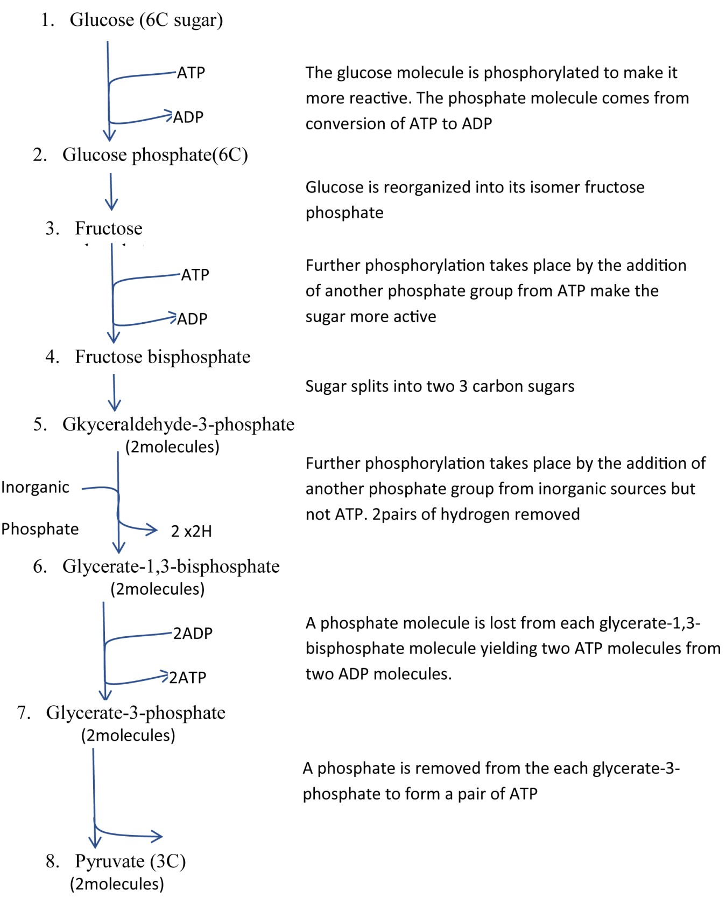

Glycolysis represents a series of reactions in which a glucose molecule is broken down into two molecules of pyruvate. Glycolysis occurs in the cytoplasm of cells, not in the mitochondria, and does not require the presence of oxygen. The process may be subdivided into two steps, first the conversion of glucose into fructose 1,6 - di-phosphate, and secondly the splitting of fructose -1,6- di-phosphate into 3C sugars which are later converted into pyruvate. Two ATP molecules are used up for phosphorylation reaction in the first step whilst four ATP molecules are produced in the second step. Four hydrogen atoms are also release. These are oxidized to water by molecular oxygen with accompanying phosphorylation of ADP to ATP molecules during oxidative. Each pair of hydrogen atom is oxidized to form 2 ATP
The ultimate fate of pyruvate depends on the availability of oxygen in the cell. If it is present, pyruvate will enter a mitochondrion and be completely oxidized into carbon dioxide and water aerobic respiration. If oxygen is unavailable pyruvate will be converted into ethanol or lactate (anaerobic respiration).
Summary
source | Number of ATP
From stages 6 and 7 | 4ATP
ATP from NADH2 | 4ATP
Total | 8ATP

Aerobic respiration.
There are two phases involved in aerobic respiration, first, if sufficient oxygen is available, each pyruvate molecule enters a mitochondrion where it is converted into a 2-carbon compound acetyl co-enzyme A (acetyl CoA for short). In this reaction carbon dioxide is given off, and the pyruvate loses a pair of hydrogen atoms which again results in the synthesis of ATP.
Acetyl CoA is a very important intermediate in respiration. It links glycolysis, oxidation of fats and proteins with the Krebs cycle.

The Krebs cycle, tricarboxylic cycles or citric cycle
- Before pyruvate enters the Krebs cycle it combines with a compound called coenzyme A to form Acetyl coenzyme A. in the process, a molecule of carbon dioxide and a pair of hydrogen atoms are removed.
- The 2-carbon acetyl coenzyme A enters the Krebs cycle by combining with a 4-carbon oxaloacetate (oxaloacetic acid to give a 6-carbon citrate (citric acid). This reaction requires energy which is provided at the expense of the energy-rich bond of acetyl group CoA.
- The citrate is degraded to a 5-carbon α-ketoglutarate (α-ketoglutaric acid) and then the 4carbon oxaloacetate by progressive loss of two carbon dioxide thus completing the cycle.
- For each turn of the cycle, a total of four pairs of hydrogen atoms are also formed.
- Of these, 3 pairs of hydrogen atoms are combined with hydrogen carrier, nicotinamide adenine dinucleotide (NAD) and yield three ATP for each pair of hydrogen atoms. The remaining pair of hydrogen atoms combine with a different hydrogen carrier, Flavine adenine dinucleotide (FAD). And yield 2 ATP.

- It must be remembered that all these products are formed from a single pyruvate molecule of which two are produced from each glucose molecule.

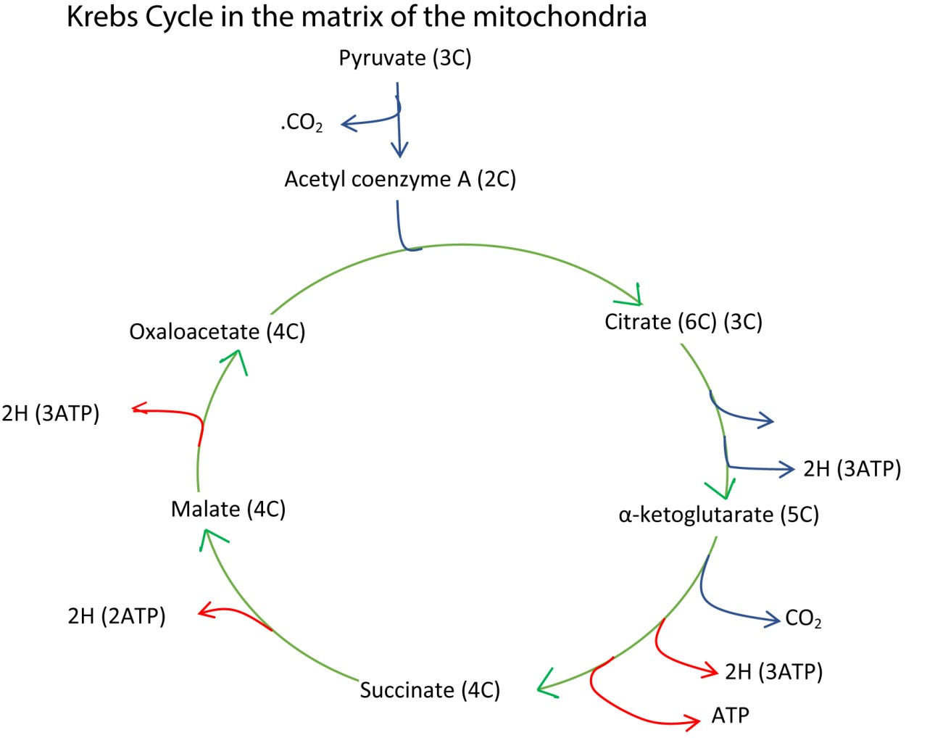
Summary
Source of ATP | Number of ATP | Total number
3 pairs if H with NAD | 9ATP | 9ATP x 2
1 pair of H with FAD | 2ATP | 2ATP x 2
Energy of the cycle | 1ATP | 1ATP x 2
Glycolysis process | 8ATP | 8ATP x 1
Pyruvate to Acetyl Co A | 3ATP | 3ATP x 2
Total |  | 38 ATP

Electron transport in the stalked membrane of the mitochondria
It occurs in the inner membranes of the mitochondria. It is the means in by which the energy, in the form of hydrogen atom, from Krebs cycle, is converted to ATP. The hydrogen atoms attached to a hydrogen carriers NAD and FAD are transferred to a chain of other carriers at progressively lower energy levels. As the hydrogens pass from one carrier to the next, the energy released is used to produce ATP. The series of carrier is called respiration chain. The carriers in the chain include NAD, Flavo protein, coenzyme Q and iron-containing protein called cytochromes. Initially hydrogen atoms are passed along the chain, but latter split into their proton and electron and only the electron pass from carrier to carrier. For this reason, the pathway can be called electron or hydrogen transport system. At the end of the chain the protons and electrons recombine, and the hydrogen atoms create a link with oxygen to form water. This formation of ATP through the oxidation of the hydrogen atoms is called oxidative phosphorylation. The role of oxygen is to act as the final electron acceptor.

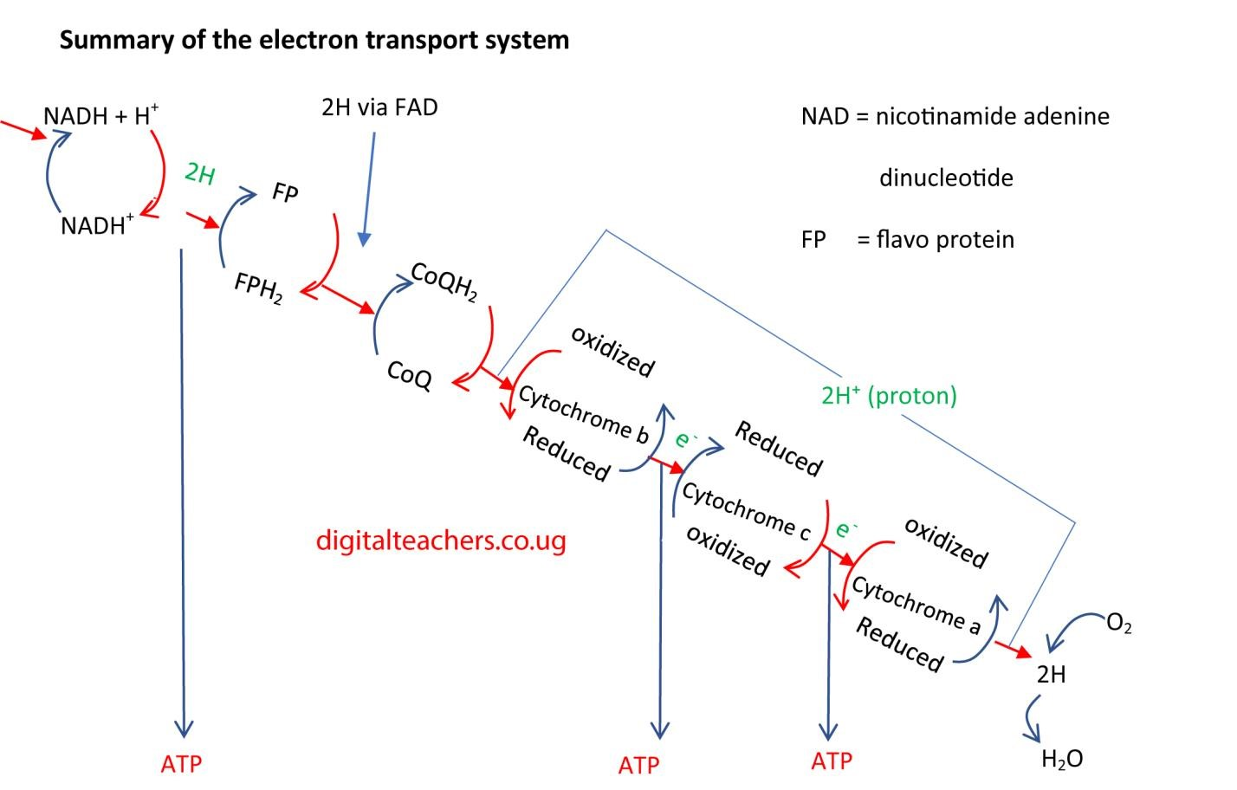

How ATP production changes during various exercise intensities
During exercise, the demand for ATP (adenosine triphosphate) can increase more than 100-fold compared to resting levels. The body meets this increasing demand by activating and transitioning between its three main energy systems: the phosphagen system, the glycolytic system, and the oxidative system. The contribution of each system changes according to the intensity and duration of the exercise.

Extreme-intensity exercise (0–10 seconds)
For very short, explosive movements, ATP is produced at a maximum rate using the fastest and most immediate energy sources.
- Phosphagen system dominates: This system uses the small stores of ATP and phosphocreatine (PCr) already present in the muscles.
- How it works: When a muscle contracts, it breaks down ATP. The enzyme creatine kinase then immediately uses the energy released from the breakdown of PCr to resynthesize ATP.
- ATP production: The phosphagen system produces a limited amount of ATP but at the highest possible rate. This pathway does not require oxygen, so it is anaerobic.
Examples: Powerlifting, a 100-meter dash, or a single max-effort jump.

High-intensity exercise (10 seconds–2 minutes)
Once the phosphagen system is depleted, the body shifts to a rapid, but less efficient, anaerobic process to continue producing ATP.
- Glycolytic system takes over: This system breaks down glucose, obtained from glycogen stores in the muscles and liver, to produce ATP.
- How it works: In a process called glycolysis, glucose is broken down into pyruvate. Because oxygen is limited during high-intensity exercise, pyruvate is converted to lactate, allowing ATP production to continue.
- ATP production: Glycolysis produces a moderate amount of ATP at a high rate but is not sustainable due to the buildup of lactate and hydrogen ions, which contributes to muscle fatigue.
Examples: A 400-meter sprint, high-intensity interval training (HIIT), and repeated heavy lifts.

Moderate-intensity exercise (2–30+ minutes)
For sustained exercise, the body transitions to the more efficient oxidative system as oxygen delivery to the muscles increases.
- Oxidative system dominates: Also known as aerobic metabolism, this system uses oxygen to generate large quantities of ATP for longer durations.
- How it works: The oxidative system uses a wider range of fuel sources, including carbohydrates (glucose) and, increasingly, fats. Pyruvate from glycolysis enters the mitochondria for the Krebs cycle and electron transport chain, which yield a much higher ATP output.
- ATP production: This process is slower than anaerobic systems but is significantly more efficient and produces enough ATP to sustain activity for prolonged periods.
Examples: Long-distance running, jogging, or cycling.

Low-intensity exercise (longer than 30 minutes)
During extended, low-intensity exercise, the body relies almost exclusively on the highly efficient oxidative system.
- Fat becomes the primary fuel: At lower intensities, the oxidative system relies predominantly on fat (fatty acids) as its fuel source. The vast energy reserves from fat stores allow for the longest possible duration of exercise.
- ATP production: Though the rate of ATP production is the slowest of the three systems, the total capacity is practically limitless, as even lean individuals have large stores of fat.
Examples: Walking, gentle swimming, or slow hiking.

Effect of cyanide on respiration
Cyanide affects respiration by poisoning the mitochondrial electron transport chain, specifically by binding to a key enzyme called cytochrome c oxidase (Complex IV). This action prevents the body's cells from using oxygen, which is essential for aerobic respiration and the production of ATP.

-

Anaerobic respiration
A variety of microorganism (anaerobes) employ anaerobic respiration as their major ATP yielding process. Organism that survive only in absence of oxygen are termed obligate anaerobes e.g. C. Brotulium and C. tetani). Obligate anaerobe find oxygen poisonous.

Other organisms such as yeast and alimentary canal parasites (such as tape worms), can exist whether oxygen is available or not. These are called facultative anaerobe. Also, some cells that are temporarily deprived of with no oxygen available to accept the hydrogen oxygen (such as muscle cells) are able to respire anaerobically.
Pyruvate serves as an electron/hydrogen acceptor in absence of oxygen to accept the hydrogen atoms released during glycolysis; and depending on the metabolic pathways within the organisms’ cells, the end-product of anaerobic respiration will either be ethanol and carbon dioxide (e.g. fermentation as in yeast) or lactate, for example lactate fermentation in muscle cells:

In Alcoholic fermentation the glucose is converted to ethanol and carbon dioxide
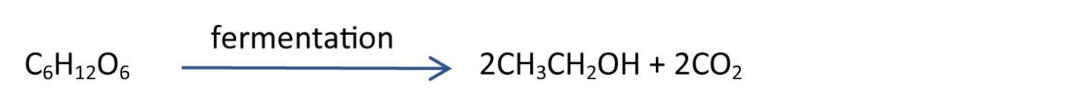
Alcoholic fermentation is the basis of brewing in which ethanol is an important product and baking industry in which carbon dioxide expands the dough.
Lactic fermentation occurs occasionally in animal cells during strenuous exercise and oxygen is insufficient. It allows animal to survive periods of insufficient oxygen. When oxygen is latter availed, lactic acid is oxidized to carbon dioxide and water or can be turned into carbohydrates. The amount of oxygen required to oxidize lactic acid accumulated in muscles is called the oxygen debt.

Differences in aerobic and anaerobic respiration
 | Aerobic Respiration | Anaerobic Respiration
Definition | Aerobic respiration uses oxygen. | Anaerobic respiration is respiration without oxygen; the process uses a respiratory electron transport chain but does not use oxygen as the electron acceptors.
Cells that use it | Aerobic respiration occurs in most cells. | Anaerobic respiration occurs mostly in prokaryotes
Amount of energy released | High (36-38 ATP molecules) | Lower (Between 36-2 ATP molecules)
Stages | Glycolysis, Krebs cycle, Electron Transport Chain | Glycolysis, Krebs cycle, Electron Transport Chain
Products | Carbon dioxide, water, ATP | Carbon dixoide, reduced species, ATP
Site of reactions | Cytoplasm and mitochondria | Cytoplasm and mitochondria
Reactants | glucose, oxygen | glucose, electron acceptor (not oxygen)
combustion | complete | incomplete
Production of  Ethanol or Lactic Acid | Does not produce ethanol or lactic acid | Produce ethanol or lactic acid

Alternative respiratory substances
- Fats are oxidized after hydrolysis to glycerol and fatty acids. Glycerol is phosphorylated, and converted into glycealdehyde-3-phosphate which is incorporated into the glycolysis pathway. Fats produce more hydrogens than glucose/carbohydrates and hence produce more energy.

- Proteins are used only in cases of starvation. They are hydrolyzed to constituent amino acids which are deaminated to form carbohydrates before converted to pyruvate.

Respiratory Quotients
The respiratory quotient (RQ) is the measure of the ratio of carbon dioxide evolved by an organism to the oxygen consumed, over a certain period.
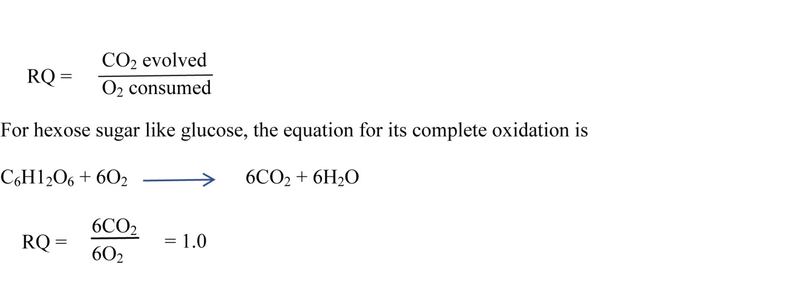
Importance:
- Knowledge of respiratory quotient helps in determining respiratory substrate.
- It helps in knowing the type of respiration being performed,
- It provides some information about major transformation of food materials.
In fats and proteins, the ratio of carbon dioxide evolved to oxygen consumed is far smaller than in carbohydrates. A fat and proteins, therefore requires more oxygen for its complete oxidation than carbohydrates. The respiratory quotient of fats is 0.7 whereas that of proteins is 0.9. Organisms rarely respire one substance at a time, thus the respiratory quotients of an animal is between 0.8 and 0.9.
Low respiratory quotient may also indicate that carbon dioxide produce is used elsewhere for example;
  - at compensation point during photosynthesis carbon dioxide produced used is in photosynthesis
  - during egg formation carbon dioxide produced is used for shell formation. Carbon dioxide is the source of carbonate ions for formation of CaCO₃ in egg shells

  - RQ is less than one when respiration is aerobic but the respiratory substrate is either fat or protein. RQ is about 0.7 for most of the common fats. It occurs during germination of fatty seeds.
C₅₇H₁₀₄O₆ + 80 O₂ → 57CO₂ + 52H₂O
(triolein)
RQ = 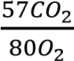 = 0.71
2(C₅₁H₉₈O₆) + 145O₂ → 102CO₂ + 98H₂O
(tripalmitin)
RQ = 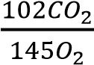 = = 0.7

RQ is about 0.9 in case of proteins, peptones, etc.

  - RQ Zero:
Succulents do not evolve carbon dioxide during night (when their stomata are open) as the same is used in carbon fixation. They also change carbohydrates to organic acids which utilise oxygen but do not evolve carbon dioxide.
2C₆H₁₂O₆ + 3O₂ → 3C₄H₆O₅ + 3H₂O RQ = Zero CO₂/3O₂ = Zero

High respiratory quotients occur
  - When carbohydrates are converted into fat e.g. when an animal is preparing to hibernate and in fattening livestock since during conversion of carbohydrates to fat carbon dioxide is liberated when pyruvate is converted Acetyl CoA. Acetyl CoA is then converted to fats without using oxygen

  - During anaerobic respiration because carbon dioxide is given out but no oxygen used.

Basal metabolic rate
Is the minimal rate of energy expenditure per unit time by endothermic animals at rest.

Factors affecting the BMR
- Body size: Metabolic rate increases as weight, height, and surface area increase.
- Body composition: Fat tissue has a lower metabolic activity than muscle tissue. As lean muscle mass increases, metabolic rate increases.
- Gender: The basal metabolic rate (BMR) averages 5 to 10 percent lower in women than in men. This is largely because women generally possess more body fat and less muscle mass than men of similar size.
- Age: A decrease in lean muscle mass during adulthood results in a slow, steady decline of roughly 0 3 percent per year in BMR after the age of about 30. This can be largely avoided by strength training throughout adulthood.
- Climate and body temperature: The BMR of people in tropical climates is generally 5 to 20 percent higher than their counterparts living in more temperate areas because it takes energy to keep the body cool. Exercise performed in hot weather also imposes an additional metabolic load. Body fat content and effectiveness of clothing determine the magnitude of increase in energy metabolism in cold environments; it takes energy to keep the body warm if you work or exercise in very cold weather.
- Hormonal levels: Thyroxine (T4), the key hormone released by the thyroid glands has a significant effect upon metabolic rate. Hypothyroidism is relatively common, especially in women near or after menopause. Everyone with a weight problem should have their thyroid function checked by their doctor and treated appropriately if it turns out to be low. 7. Health: Fever, illness, or injury may increase resting metabolic rate two-fold

Revision Exercise
Objective questions
- Lactic acid accumulation in muscles of an athletic during action is due to B
  - Oxygen debt
  - Anaerobic respiration
  - Panting
  - High rate of respiration
- The end product of glycolysis D
    - Glucose diphosphate
    - Lactic acid
    - Citric acid
    - Pyruvic acid
- The following process does not require respiratory energy? C
    - Synthesis of cellulose
    - Meiosis
    - Loss of water from the stomata
    - Mineral absorption
- Which of the following are formed during anaerobic respiration in yeast cell? C
    - Lactic acid and ATP
    - Lactic acid and ADP
    - Ethanol and ATP
    - Ethanol and ADP
- How many kilojoules of energy are released if 1 gram of sugar burned in oxygen A raises the temperature of 500g of water by 7.5⁰C, (4.18J raise the temperature of 1 gram of water by 1⁰C)
    - 15.7kJ
    - 156kJ
    - 1.56kJ
    - 1560kJ
* Heat liberated = mcθ = 500 x 4.18 x 7.5 = 15,675J = 15.7kJ
- What happens to most of the reduced NADH2 molecules metabolism? B
  - Direct use in the synthesis of starch to glucose
  - Oxidation in mitochondria resulting in ATP formation
  - Oxidation in Calvin cycle
  - Combination with sulphuric acid as part of Krebs cycle
- Which of the following will speed of phosphorylation of the Hexose sugar? C
  - Decrease of ADP concentration
  - A decrease in the concentration of ATP
  - An increase in the concentration of the phosphate
  - An increase in the concentration of phosphorylated hexose
* Phosphate is a reactant, increasing the concentration of reactant speeds reaction
8. An athletic had just finished a race; the phrase “oxygen debt” refers to D
- The amount of oxygen originally present in the muscle of an athlete before the race
- The total amount of oxygen an athlete requires to restore the breathing rate to normal
- The amount of oxygen taken in after the race and used for complete combustion of lactic acid
- The amount of oxygen after the race to convert excess lactic acid to glycogen in the liver.
* "Oxygen debt" (or the modern term, excess post-exercise oxygen consumption, EPOC) refers to the extra oxygen consumed by the body after strenuous exercise to restore all systems to their normal pre-exercise state.
A key part of this recovery process is the removal of accumulated lactic acid, a byproduct of anaerobic respiration during intense activity when the oxygen supply is insufficient. The lactic acid is transported by the blood to the liver, where the extra oxygen is used to convert most of it back into glucose, which is then often stored as glycogen.

- Which of the following biological processes does not utilize respiratory energy? A
  - Loss of water from stoma
  - Mineral salt absorption
  - Synthesis of cellulose
  - Meiosis
- Which one of the following compounds act as hydrogen acceptor during anaerobic D respiration in animals?
  - NAD
  - NADP
  - Lactic acid
  - Pyruvic acid
* Anaerobic respiration in animals is lactic acid fermentation. When there is a lack of oxygen, such as during intense exercise, animal cells perform anaerobic respiration, converting glucose to lactic acid to generate energy.
Pyruvic acid accepts hydrogen from NADH. During this process, pyruvic acid, which is the end product of glycolysis, acts as the hydrogen acceptor. It takes hydrogen from NADH to become reduced to lactic acid. This reaction, catalyzed by the enzyme lactate dehydrogenase, regenerates NAD⁺ so that glycolysis can continue to produce a small amount of ATP in the absence of oxygen.

11. Which one of the following is not a method of measuring the rate of respiration in A an organism?
- Estimating the amount of food taken in by the organism per day
- Measuring the heat produced by the organism in a given time
- Measuring the amount of CO₂ produced by an organism in a given time
- Estimating the amount of oxygen consumed by the body in a given time
* Respiration is the process of energy release. The rate of respiration refers to how quickly an organism breaks down food to release energy. Measuring food intake only tells you how much potential energy the organism is taking in, not how fast it is being used.
- The substance that supplies phosphate at the beginning of glycolysis is B
  - Adenosine diphosphate (ADP)
  - Adenosine triphosphate (ATP)
  - Adenosine monophosphate (AMP)
  - Nicotinamide adenine dinucleotide phosphate (NADP)
- The following are physiological conditions in living cells C
  - High concentration of ADP and Pi
  - High concentration ATP
  - High concentration of hydrogenase
  - High concentration of ATPase
Which of them will increase the rate of sugar down
  - 1 and 2
  - 2 and 3
  - 1 only
  - 4 only

* The rate of sugar breakdown (cellular respiration/glycolysis) is highly regulated by the cell's energy needs.
- High concentration of ADP and Pi: ADP (adenosine diphosphate) and Pi (inorganic phosphate) are the products of ATP hydrolysis, meaning the cell has low energy reserves. High levels of ADP and Pi allosterically activate key regulatory enzymes in glycolysis and the Krebs cycle, such as phosphofructokinase-1 (PFK-1), thereby increasing the rate of sugar breakdown to produce more ATP.
- High concentration of ATP: A high concentration of ATP signals that the cell has sufficient energy. ATP acts as an allosteric inhibitor of key glycolytic enzymes (like PFK-1 and pyruvate kinase), which slows down sugar breakdown to conserve the glucose supply when energy is not needed.
- High concentration of hydrogenase: Hydrogenases are enzymes that catalyze the reversible reaction between hydrogen gas and protons/electrons. They are not directly involved in the main pathways of sugar breakdown in typical animal or plant cells.
- High concentration of ATPase: ATPases are enzymes that break down ATP into ADP and Pi, releasing energy for cellular work. While they increase the concentration of ADP and Pi (which in turn promotes sugar breakdown), the presence of more ATPase itself represents an increased demand for ATP consumption, rather than a direct increase in the rate of sugar breakdown as a primary regulatory condition. The low ATP/high ADP condition is the actual signal.

14. A rat requires more energy per unit body weight than required by human because D the rat
- Has a large surface area
- Is more active
- Has higher body temperature
- Has a higher metabolic rate
* To meet high rate of heat loss due to its large surface area to volume ratio
15. In which of the following does anaerobic respiratory not occurs? D
- Skeletal muscle
- Yeast cell
- Bacterial
- Smooth muscle
* Anaerobic respiration is for short, intense energy bursts. This process, also known as fermentation, provides a quick but inefficient way to produce ATP without oxygen. It occurs in cells that experience periods of oxygen shortage due to high energy demand.
Smooth muscle has a steady, low-energy demand. Smooth muscle, which is found in the walls of internal organs and blood vessels, performs sustained, involuntary contractions rather than rapid, powerful movements. Its metabolic needs are typically met by aerobic respiration, which is far more efficient in producing ATP.

16. The life process which releases most energy is C
- The light reaction of photosynthesis
- Fermentation of glucose
- Aerobic cellular respiration of glucose
- The oxidation of lactic in mammalian of muscle cells
* Aerobic respiration yields the most ATP. Cellular respiration is the process of breaking down glucose to release energy in the form of ATP. Aerobic respiration, which uses oxygen, completely breaks down one glucose molecule to yield a high amount of ATP, typically 30 to 38 ATP molecules.
Other processes are less efficient. Fermentation (anaerobic respiration) and other partial breakdowns of glucose release significantly less energy. For example, fermentation of a single glucose molecule produces only 2 ATP.

17. The respiration of the fat tri olein can be summarized as the follows by the equation C
C₅₇H₁₀₄O₆ + 80O₂ → 57CO₂ + 52H₂O
Which of the following resents the respiratory quotient (RQ) for this fat?
- 1.5
- 1.4
- 0.71
- 0.65
* RQ = 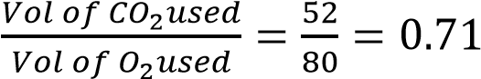
- Which biological process takes place in the mitochondrion? C
  - Glycolysis
  - Formation of lactic acid
  - Tricarboxylic cycle
  - Alcoholic fermentation
- Which of the following conversion takes place in human under conditions of B starvation?
  - Fatty acids to carbohydrate
  - Proteins to carbohydrates
  - Glucose to lipids
  - Lipids to lipoproteins
- During which one of the following is the respiratory quotient most likely to be high D
  - In plants during bright light
  - In animals during laying down of fats
  - During egg laying in birds
  - During lactic acid formation

* • Lactic acid formation is a form of anaerobic respiration in which oxygen consumption is significantly reduced.
• During intense exercise, the accumulation of lactic acid leads the body to expel more carbon dioxide to buffer the acidity, causing the respiratory exchange ratio (a measure equivalent to RQ during exercise) to rise and potentially exceed 1.0, sometimes even reaching values above 2. This combination of high 2 output and low oxygen use results in a very high RQ.
- The figure below shows some reactions in the respiratory pathway A



CO
2

Pyruvic acid

Acetyl CoA

NADH
2

x

The enzyme which catalyzes the reaction marked X is
  - Pyruvate dehydrogenase
  - Acetyl CoA dehydrogenase
  - Pyruvate decarboxylase
  - Acetyl CoA decarboxylase
- During strenuous activity, the pyruvic acid in the muscle may accept hydrogen from B reduced NADH to become
  - Acetyl CoA
  - Lactic acid
  - Ethanol
  - Citric acid
- The equation for complete oxidation of a substance is A
2C₁₈H₃₄O₂ + 51O₂ 36CO₂ + 34H₂O

The respiratory quotient for oxidation is
  - 0.70
  - 1.4 C. 0.9
D. 1.0
* RQ = 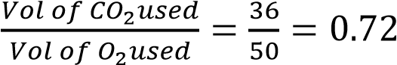
24. Which of the following is liberated during both aerobic and anaerobic respiration? A
- Carbon dioxide and energy
- Ethanol and water
- Water and carbon dioxide
- Carbon dioxide and ethanol
* Aerobic respiration: This process uses oxygen to completely break down glucose, yielding a large amount of energy (ATP). The waste products are carbon dioxide and
water.
Anaerobic respiration: This process occurs without oxygen and produces much less energy. In organisms like yeast, the products are ethanol and carbon dioxide. In animals, the product is lactic acid, but this process still releases a small amount of energy.
Therefore, carbon dioxide and energy are liberated in both aerobic and some forms of anaerobic respiration, such as in yeast

25. In endergonic reaction, the products of the reaction contain C
- More energy than the reactants and energy is released
- Less energy than the reactants and energy is absorbed
- More energy than the reactants and energy is supplied
- Less energy than the reactants and energy is released
* Endergonic reaction defined: An endergonic reaction is a chemical reaction that requires an input of energy from its surroundings to proceed.
Energy storage: Because energy is absorbed (supplied) during the reaction, this energy is stored within the chemical bonds of the products.
Result: Consequently, the products of an endergonic reaction contain more potential chemical energy than the original reactants.

- Which of the following is the ultimate hydrogen acceptor during anaerobic C respiration?
  - Lactic acid
  - NAD
  - Pyruvic acid
  - Acetaldehyde

- Which one of the following is unlikely to be found in the body of obligate anaerobes? C A. Glycolytic enzymes
  - ATP
  - Mitochondria
  - Acetaldehyde
* Mitochondria are the "powerhouses" of the cell that perform aerobic respiration. This process requires oxygen as the final electron acceptor to produce a large amount of ATP.
Obligate anaerobes cannot survive in the presence of oxygen and therefore rely on anaerobic respiration or fermentation for energy.
Since mitochondria are the sites of aerobic respiration, they are not found in prokaryotic obligate anaerobes (like bacteria). Even in some anaerobic eukaryotes, typical mitochondria are replaced by other organelles like hydrogenosomes or mitosomes that perform anaerobic metabolism.
28. The figure shows that B



A.

NAD is oxidized to NADH
2

H
2

NAD

NADH
2

FADH
2

FAD

H
2

H
2

- NADH₂ is reduces FAD to FADH₂
- FADH₂ is reduced is reduced to FAD
- NADH₂ + H₂ →NAD
* Reduction is addition of hydrogen to a compound
- Anaerobes thrive better than aerobic organism in water experiencing thermal C pollution because
  - High temperatures kill aerobic organisms
  - Anaerobes possess enzymes that work best at high temperatures
  - High temperatures reduce solubility of oxygen
  - High temperatures encourage multiplication of aerobes predators.
- A major difference between respiration and burning is that D
  - no heat is produced during respiration
  - burning is a faster process
  - burning is a chemical process
  - chemical energy is stored in respiration
- Compared to carbohydrates, fats have high energy value because fats B
  - have long chains of fatty acids
  - have a higher proportional of hydrogen
  - are more compact in structure
  - have a high proportion of oxygen

- The compound which acts as oxidizing agent during anaerobic respiration in plants B
  - NAD and pyruvate
  - Ethanal and NAD⁺
  - NAD and FAD
  - NADP and pyruvic acid
* The compound which acts as an oxidizing agent (accepts hydrogen/electrons) during anaerobic respiration in plants is ethanal and NAD+
33. Which of the following increases the rate phosphorylation of hexose sugar during A the normal respiration process?
- An increase in ADP concentration
- An increase in ATP concentration
- An increase in concentration of hexose sugar
- A decrease in concentration of phosphorylated sugar
* ADP indicates low energy. An increase in the concentration of adenosine diphosphate (ADP) signifies that the cell has low levels of available energy (ATP).
Metabolic regulation: The cell's metabolism is regulated to meet its energy demands. High concentrations of ADP act as a signal to activate key regulatory enzymes in glycolysis, the pathway for sugar breakdown.
Driving glycolysis forward: By activating these enzymes, a high ADP concentration increases the overall rate of glycolysis, including the initial phosphorylation of the hexose sugar, in order to produce more ATP and restore the cell's energy balance.

- Which one of the following activities in living organisms can result in a respiratory B quotient of less than 1.0?
  - When carbohydrates are respired
  - During extensive laying, down of fat in livestock
  - At compensation point, during photosynthesis
  - When the rate of exhalation equals that of inhalation.
- A rat requires more energy per unit body weight than that required by a human D because a rat
  - Has a larger surface area
  - Is more active
  - Has higher body temperature
  - Has a higher metabolic rate
- Lipids are better energy sources than carbohydrates is that D
  - Are insoluble
  - Do not form hydrogen bonds with water
  - Are more compact
  - Have a higher proportion of hydrogen
- Which one of the following changes occur in mammalian body at the onset of an C exercise?
  - Increase in the pH of blood
  - Decrease in the rate of contraction of the diaphragm muscles
  - Increase in the rate of tissue respiration
  - Decrease in the amounts of water vapor in the breath
- Fats yield more energy per unit mass than carbohydrates because fats possess B
  - More carbon atoms
  - More hydrogen atoms
  - Few carbon atoms
  - Fewer oxygen atoms
- Which one of the following best describes basal metabolic rate? D
  - Average amount of energy produced by the body
  - Average amount of energy produced when at rest
  - Amount of energy produced by an average body
  - Amount of energy produced when all voluntary movement have ceased.
* Basal Metabolic Rate (BMR) is the energy expenditure at a state of complete rest. It is the minimum amount of energy the body needs to perform essential, lifesustaining functions such as breathing, blood circulation, and cell production.
- Lactic acid accumulation in the muscle of an athlete during action is due to B
  - Oxygen debt
  - Anaerobic respiration
  - Panting
  - High rate of respiration
- In which one of the following parts of the cell does most production of ATP occurs? B
  - Matrix of mitochondria
  - Cristae of the mitochondria
  - Cytoplasm of the cell
  - Outer membrane of the mitochondria
- Which one of the following is not a method of measuring the rate of respiration in A an organism?
  - Estimating the amount of food taken in by the organism per day
  - Measuring the heat produced by the organism in a given time
  - Measuring the amount of carbon dioxide produced by an organism in a given time
  - Estimating the amount of oxygen consumed in a given time
- In an individual whose energy intake is 50000kJ per day, loses 1dm³ of sweat in a C day during manual work. Given that the latent heat of vaporization of sweat is
2.45kJcm⁻³, the percentage of energy lost by the individual during the work is A. 4.22
  - 5.0
  - 4.9
  - 7.65
* 1dm³ = 1000cm³
Heat lost through sweating = 2.45kJcm⁻³ x 1000cm³ = 2450kJ
Percentage energy lost = 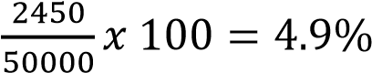
44. The latent heat of evaporation of sweat is 3.15kJcm⁻³. What is the percentage of D energy lost by sweating from a manual worker who loses 2dm³ per day of sweat and has a daily energy intake of 40,000kJ?
A. 6.30 B. 7.88
- 8.25
- 15.75
* 1dm³ = 1000cm³
Heat lost through sweating = 3.15kJcm⁻³ x 2000cm³ = 6300kJ
Percentage energy lost = 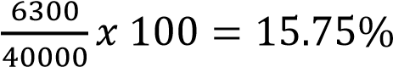
- In which of the following does anaerobic respiration not occur D
  - Skeletal muscles
  - Yeast cell
  - Bacteria
  - Smooth muscle
- Which one of the following food materials has the highest amount of potential D energy per unit weight?
  - Proteins
  - Vitamins
  - Monosaccharide
  - Fats
- Which one of these activities would result into a low respiratory quotient? D
  - Respiration in muscles during heavy exercise
  - Formation of calcareous shells
  - Fattening livestock
  - Preparation for hibernation in a mammal.
* A low respiratory quotient (RQ) indicates that an organism is primarily metabolizing fats as its energy source. The RQ for fat metabolism is approximately 0.7, while for carbohydrates it is 1.0.
• Preparation for hibernation: Mammals preparing for hibernation need to store large amounts of energy to survive the long, dormant period. They do this by eating and storing significant amounts of fat. Just before and during the early stages of hibernation, they primarily rely on the breakdown of these stored fats for energy. This fat metabolism, which requires a high
amount of oxygen for every molecule of carbon dioxide produced, results in a low RQ.

Why other options are incorrect
- A. Respiration in muscles during heavy exercise: During heavy exercise, muscles often switch to anaerobic respiration, producing a high amount of carbon dioxide (to buffer lactic acid) with limited oxygen consumption. This leads to a high RQ, often greater than 1.0.
- B. Formation of calcareous shells: The formation of calcareous shells in aquatic organisms involves the removal of carbon dioxide from the surrounding water, which is a process separate from the primary metabolic respiration that determines the RQ. This process is not directly related to a low RQ.
- C. Fattening livestock: This process, also known as lipogenesis, involves converting excess carbohydrates into fat for storage. This conversion produces carbon dioxide without a corresponding increase in oxygen consumption, which can lead to an RQ greater than 1.0.
48 The equation for respiration of a substrate is A
2C₅₁H₉₈O₆ + 145O₂ (g) → 102CO₂ (g) + 98H₂O(l) What is the respiratory quotient of substrate?
- 0.70
- 0.80
- 0.90
- 1.0

* RQ = 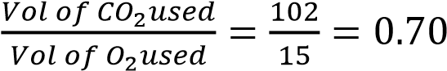
49 During respiration in the absence of oxygen, pyruvic acid is converted B
- lactic acid and water
- ethanol and carbon dioxide in plants
- lactic acid and carbon dioxide in plants
- ethanol and water in plants

Structured questions
50. Fill in the missing using appropriate words (s) so as to complete the account of cellular respiration
‘the initials stage in cellular respiration is glycolysis which occurs with occur in the ………………………. of the cell. A monosaccharide such as ……………………. is first ………………………. Then converted into a 3-carbon intermediate product called ……………….

In the absence of oxygen this product may enter another metabolic pathway giving rise to
……………………………. in animals and …………………… in plants. The end product of glycolysis is ………………. which is decarboxylated and enter the …………………. Cycle. This cycle links other pathways which enables organism acid such as ……………………………….. and …………………………. To be regarded and small organic molecules in the cycle provides …………………… uses into the reduction of ………………………… during cycle a total of ……………… molecules are formed from complete oxidation per molecule of a 6-carbon sugar
Answer
The initial stage in cellular respiration is glycolysis which occurs in the cytoplasm of the cell. A monosaccharide such as glucose is first phosphorylated (or activated) then converted into a 3carbon intermediate product called pyruvic acid (or pyruvate).
In the absence of oxygen this product may enter another metabolic pathway giving rise to lactic acid in animals and ethanol (and carbon dioxide) in plants. The end product of glycolysis is pyruvic acid which is decarboxylated and enters the Krebs (or Citric Acid) cycle. This cycle links other pathways which enables organic acids such as fats (lipids) and proteins (amino acids) to be degraded, and small organic molecules in the cycle provide acetyl CoA (uses into the reduction - this phrase is unclear in the original prompt) to the cycle. During the cycle a total of 38 (or 30-32) molecules of ATP are formed from complete oxidation per molecule of a 6carbon sugar.

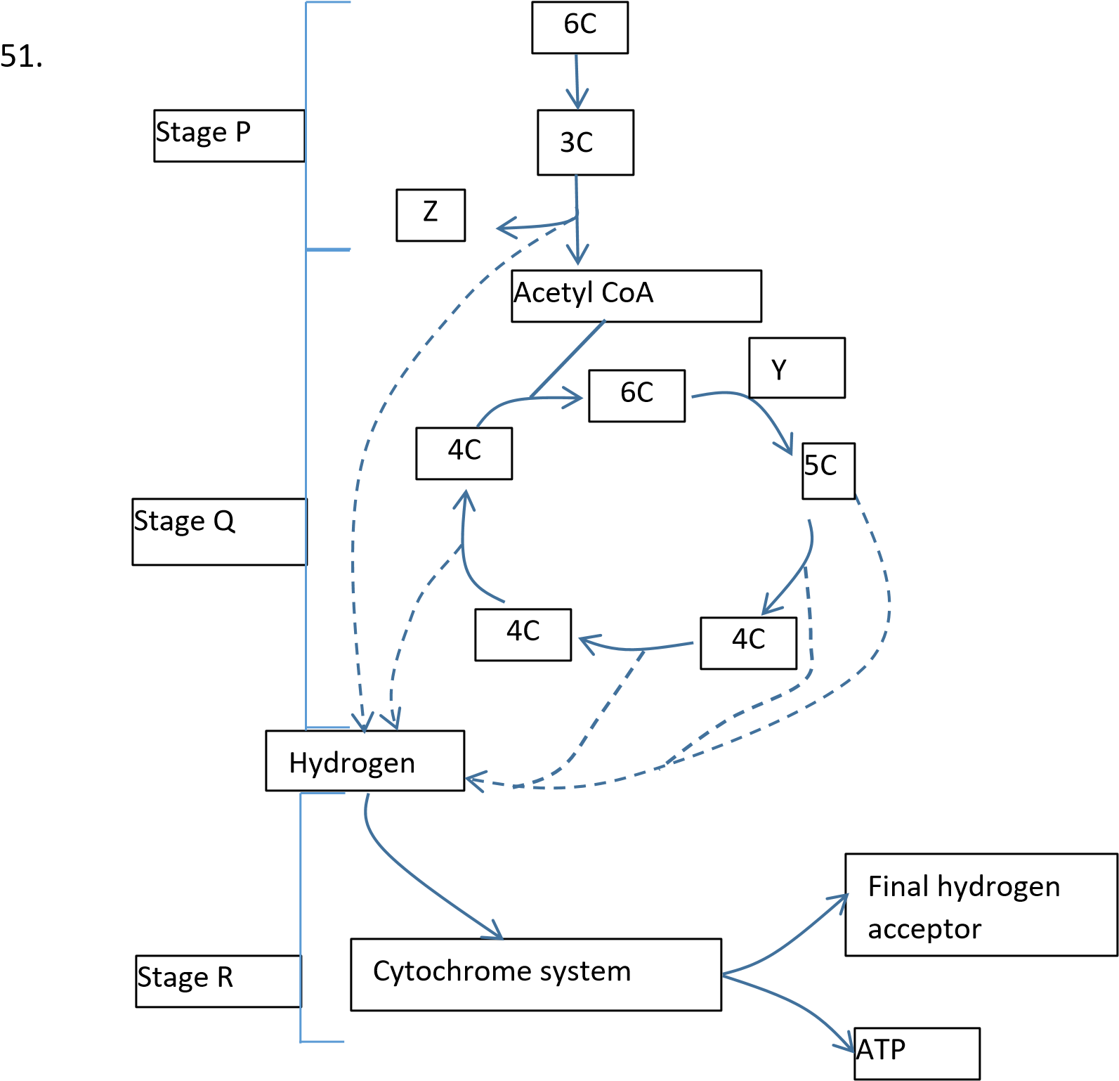

- Where exactly do reactions P, Q and R occur?
  - glycolysis in cytoplasm
  - – Kreb’s cycle in matrix of mitochondria
  - electron transport system in cristae, the folds of the inner mitochondrial membrane.
- What is substance Z? CO₂
- What is the 6C intermediate compound from the reaction between acetyl CoA and the 4C compound
Citrate
- Name the enzyme controlling reaction Y decarboxylase
- Name the final hydrogen acceptor in the cytochromes system indicated in the diagram Oxygen
- (i) Define the term respiratory Quotient (RQ)

The Respiratory Quotient (RQ) is a dimensionless number defined as the ratio of the volume of carbon dioxide (₂) produced to the volume of oxygen (₂) consumed during respiration
- Glucose has a formula C₆H₁₂O₆ and tripalmitin has the formula
C₅₁H₉₉O₆. The two substances when completely oxidized have the following overall equation.
C₆H1₂O₆ + 6O₂ 6CO₂ + 6H₂O
C₅₁H₉₉O₆ + 145/2O₂ 51CO₂ + 49H₂O
Using the above equations calculate RQ values for aerobic respiration of tripalmitin
RQ = 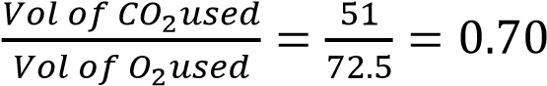
- State the RQ value of glucose in anaerobic respiration. Explain your answer.
In plants RQ is infinite because CO2 is produced with no oxygen consumed
In animals RQ = 0, no oxygen used and no carbon dioxide produced
52. (a) Differentiate between respiratory quotient (RQ) and basal metabolic rate (BMR) The Respiratory Quotient (RQ) is a dimensionless number defined as the ratio of the volume of carbon dioxide (2) produced to the volume of oxygen (2) consumed during respiration

Basal Metabolic Rate (BMR) is the minimum amount of energy (calories/kilojoules) the body requires to maintain essential, life-sustaining functions while at complete physical, mental, and digestive rest.
(b) The table below shows the respiratory quotient in germinating seeds under difeerent treatment
Treatment RQ
- 4hrs soaking in water 6.0
- 4hr soaking then 4 hour exposure to air 1.8
- 4hour soaking the 24hrs exposure to air 1.0

Explain the difference respiratory quotients of the germinating seeds under the
different treatment. (06 marks)

When the seeds are not exposed to air, there is inadequate oxygen supply and absorption. The seeds respire an aerobically to produce carbon dioxide.
The volume of carbon dioxide released by the seeds in respiration far exceeds that of oxygen consumed and the RQ is greater than 1.0.
When exposed to air for 4hrs, the volume of oxygen absorbed by the seeds increases. Then, here is a combination of aerobic and anaerobic respiration occurring. However, the volume of carbon dioxide produced exceeds that of oxygen consumed and the RQ is still above 1.0 but less than in (i) above.
When exposed to air for air 24hrs, the volume of oxygen absorbed is adequate for the plant of rely solely on aerobic respiration for its energy needs.
Since carbohydrate is the main energy substrate in the need, complete respiration consumers the same volume oxygen as the volume of carbon dioxide produced and so the RQ is 1.0.
(c) Explain why the BMR varies with age of individual (02marks)
Basal Metabolic Rate (BMR) varies with age due to significant changes in body composition, hormonal levels, and the energy required for growth.
- (a) Name the organelle most imortant in photosynnthesis and respiration
(i) Photosynthesis: chloroplast (ii) Respiration: Mitochondrion
  - Give four differences and five similarities between the two organelles (i) Differences

Differences between chloroplast and mitochondria
 | Chloroplast | Mitochondria
1 | They are usually found in plants | They are found in plants and animal cell
2. | They convert light energy into chemical energy (sugar) | Breakdown chemical energy (sugar) into another form of chemical energy (ATP)
3. | Contain chlorophyll | Lack chlorophyll
4. | Inner membrane is thylakoid | Inner membrane is cristae

(ii) Similarities
      - Both produce energy
      - Each has its own DNA
      - Each is enclosed by two membranes
      - Both have extensive membrane systems inside
      - Both have matrix
- (a) Give an account of glycolysis
Ref. page 4
  - Explain what happened to the pyruvate under aerobic conditions.
Under aerobic conditions (in the presence of sufficient oxygen), the pyruvate molecules produced during glycolysis in the cytoplasm are transported into the mitochondria to undergo further oxidation, primarily through the Krebs cycle and the electron transport chain.
    - Transport into the Mitochondrion: The two molecules of pyruvate (a 3-carbon compound) produced from one molecule of glucose in the cytoplasm are actively transported across the outer and inner mitochondrial membranes into the mitochondrial matrix.
    - The Link Reaction (Oxidative Decarboxylation): Once in the matrix, each pyruvate molecule undergoes a critical transformation known as the link reaction (or pyruvate dehydrogenase complex reaction):
      - Decarboxylation: A carbon atom is removed from pyruvate in the form of a molecule of carbon dioxide (𝐶𝑂₂). This is the first 𝐶𝑂₂ produced during aerobic respiration.
      - Oxidation and NAD⁺ Reduction: The remaining 2-carbon unit is oxidized. The energy from this oxidation is used to reduce a molecule of NAD+ to NADH, which is a high-energy electron carrier.
      - Formation of Acetyl CoA: The 2-carbon unit is then attached to a coenzyme called Coenzyme A (CoA) to form acetyl CoA (acetyl coenzyme A).
The net result for the two pyruvate molecules is two molecules of acetyl CoA, two molecules of 𝐶𝑂2, and two molecules of NADH.
    - The Krebs Cycle (Citric Acid Cycle): The acetyl CoA molecules then enter the Krebs cycle, which also takes place in the mitochondrial matrix:
      - Entry: Each acetyl CoA (2C) combines with a 4-carbon compound called oxaloacetate to form a 6-carbon compound called citrate.
      - Cycle of Reactions: The citrate molecule goes through a series of reactions that generate energy carriers and produce waste products:
        - It is gradually oxidized and converted back to oxaloacetate, continuing the cycle.
        - 𝐶𝑂₂ is released. o More NADH and FADH₂ (another high-energy electron carrier) are produced. o A small amount of ATP is produced directly (substrate-level phosphorylation).
    - Electron Transport Chain and Oxidative Phosphorylation:The NADH and FADH₂ generated during the link reaction and the Krebs cycle carry high-energy electrons to the inner mitochondrial membrane (cristae).
      - Electron Flow: The electrons are passed down a series of protein complexes (the electron transport chain or cytochromes system).
      - ATP Production: The energy released from the movement of these electrons is used to pump protons across the membrane, creating a gradient that drives the production of large amounts of ATP via ATP synthase (oxidative phosphorylation).
      - Final Acceptor: At the end of the chain, oxygen acts as the final electron acceptor, combining with hydrogen ions to form water (𝐻₂𝑂).

- (a) Distinguish between aerobic respiration and anaerobic respiration (b) Outline the major steps involved in the process of glycolysis in a cell.
  - How is energy produced in glycolysis?
- (a) Differentiate between aerobic and anaerobic respiration. (05marks)

Feature | Aerobic Respiration | Anaerobic Respiration
Oxygen  Requirement | Requires oxygen (𝑂₂) | Occurs in the absence of oxygen
Oxidation of Glucose | Complete breakdown of glucose | Incomplete breakdown of glucose
Energy Produced (ATP) | High yield (approx. 36– 38 ATP per glucose) | Low yield (approx. 2 ATP per glucose)
End Products | Carbon dioxide (𝐶𝑂₂) and water (𝐻2𝑂) | Lactic acid (in animals) or ethanol and 𝐶𝑂₂ (in plants/yeast)
Location in Cell | Cytoplasm and mitochondria | Cytoplasm only
Rate of Reaction | Slower, sustained process | Faster, for quick bursts of energy
Final Electron Acceptor | Oxygen (𝑂2) | An inorganic molecule other than oxygen (e.g., nitrate, sulfate) or an organic molecule (e.g., pyruvate, acetaldehyde)
Organisms | Most higher organisms  (plants, animals, humans) | Lower organisms (bacteria, yeast) and muscle cells during intense exercise

- Describe what happens to the end product of glycolysis in absence of oxygen
(10marks)
In the absence of oxygen, the end product of glycolysis, pyruvic acid (pyruvate), enters a metabolic pathway called fermentation. The specific end products of fermentation vary depending on the type of cell: In Animal Cells (Lactic Acid Fermentation)
In animal cells, such as muscle cells during strenuous exercise when oxygen is limited, pyruvate is converted to lactic acid (lactate).
  - Process: Pyruvate acts as the hydrogen acceptor and is reduced by NADH (a highenergy carrier molecule produced during glycolysis).
  - Purpose: This reaction is catalyzed by the enzyme lactate dehydrogenase. Crucially, this process regenerates NAD⁺ from NADH.
  - Outcome: The regeneration of NAD⁺ allows glycolysis to continue producing a small amount of ATP in the absence of oxygen, providing short-term energy to the muscle cells. Lactic acid is later transported to the liver and converted back into glucose when oxygen is available (clearing the oxygen debt).
In Plant Cells and Yeast (Alcoholic Fermentation)
In most plant cells and in yeast cells, pyruvate is converted to ethanol (alcohol) and carbon dioxide.
  - Process: This is a two-step process:
      - Pyruvate is first decarboxylated (loses a carbon dioxide molecule) to form acetaldehyde.
      - Acetaldehyde is then reduced by NADH to form ethanol.
    - Purpose: Similar to lactic acid fermentation, this process regenerates NAD⁺ from NADH, allowing glycolysis to continue and produce ATP.
    - Outcome: Ethanol and carbon dioxide are the waste products of this process, which is used commercially to produce alcoholic beverages and bread (where 𝐶𝑂₂ causes the dough to rise).

- Why is it important to produce ATP during cellular respiration?
(05marks)
ATP provides energy for all the biological processes such breathing, heartbeat, locomotion, growth etc.
- An investigation was carried out into the effects of athlete training on respiration in human muscle. A group of athlete and non-athlete exercised at different levels. The level of exercise was expressed as rates of energy expenditure Jmin⁻¹kg⁻¹ of body mass. At each level, rates of oxygen consumption and lactic acid production were measured, the results are shown in the table below. Figures in the table are the means of the measurements made for each group.

Rate of energy  Expenditure in Jmin⁻¹kg⁻¹ | Rate of oxygen consumption in cm³min⁻¹kg⁻¹ |  | Rate of lactic acid production in mgmin⁻¹kg⁻¹
Rate of energy  Expenditure in Jmin⁻¹kg⁻¹ | Athletes | Non-athletes | Athletes | Non-  athletes
600  800  1000  1200  1400 | 30  40  50  57  58 | 29  39  44  45  45 | 0  0  0  85  305 | 0  0  185  350  590

  - Plot graphs to show the relationship between the rate of oxygen consumption and lactic acid production against the level of activity in the two groups.
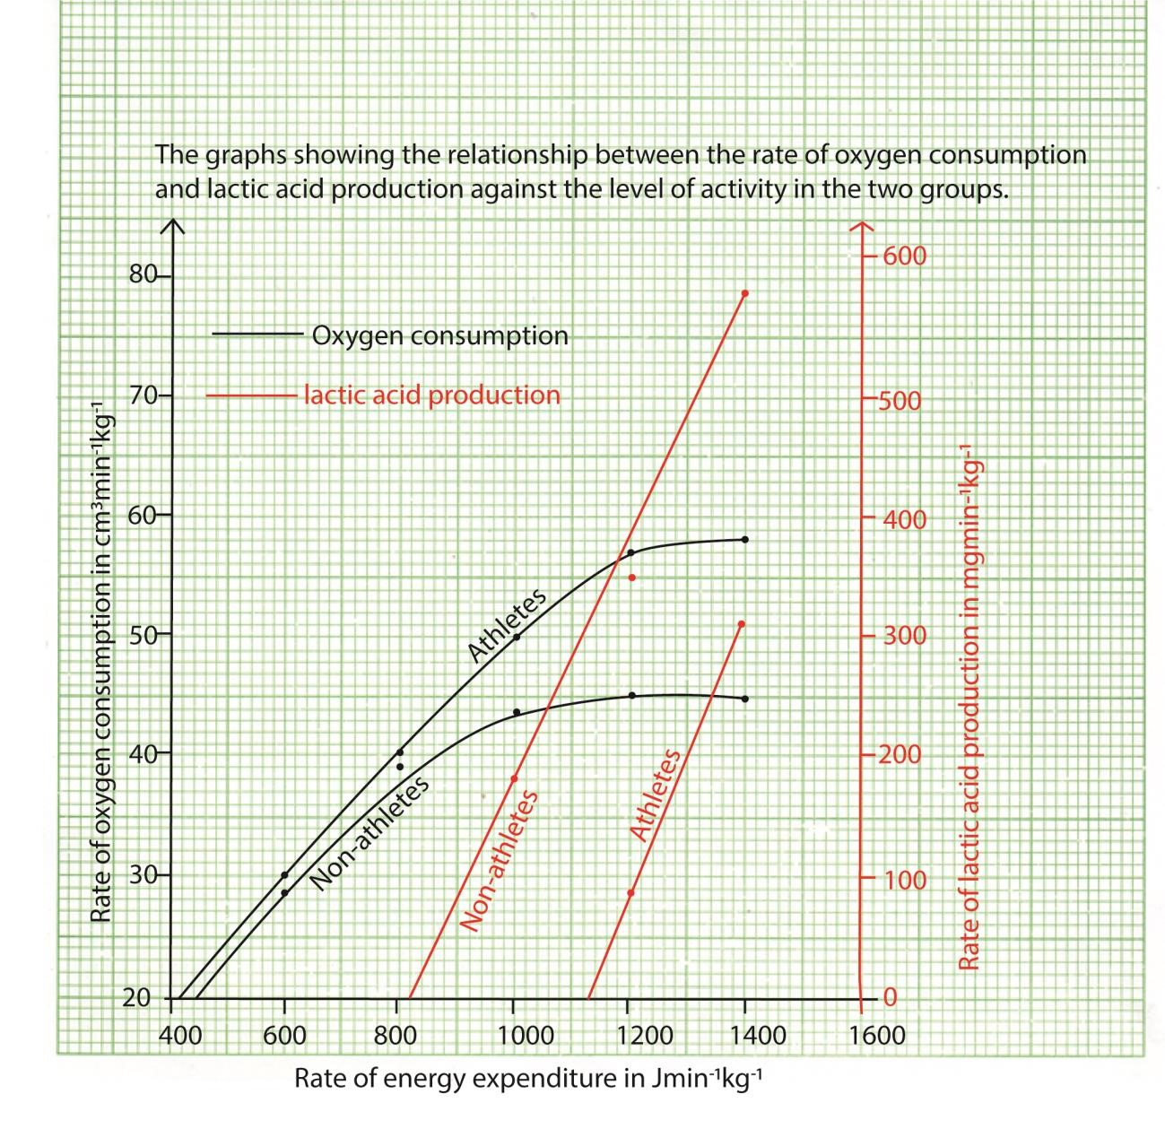
Or the different categories of graphs can be drawn separately

  - Using your graphs in (a) describe the effect of increasing the level of exercise on the rates of oxygen consumption and lactic acid accumulation in
    - Athletes
        - An increase in the level of activity leads to steady/gradual/uniform rise in the rate of oxygen consumption up to the level of 1000 after which the rate of increase is slower and tend to level off.
        - Lactic acid accumulation increases exponentially after energy consumption goes beyond 1000JMin⁻¹kg⁻¹.

    - Non-athletes
        - An increase in the level of activity leads to steady/gradual/uniform rise in the rate of oxygen consumption up to the level of 1000 after which the rate of increase is slower and tends to level off.
        - Lactic acid accumulation increases exponentially after energy consumption goes beyond 800JMin⁻¹kg⁻¹.
  - How do the two groups of people compare in their abilities to consume oxygen and accumulate lactic acid during the exercise?
    - Athletes consume oxygen at a higher rate than non-athletes
    - Non-athlete produce more lactic acid than athletes
    - Non athlete starts to produce lactic acid at lower rate of energy consumption.

  - Using the data provided, suggest any advantage an athlete has over a non-athletes.

Athletes consume more oxygen leading to complete respiration producing more energy then non-athlete. They thus produce less lactic acid.

- An experiment was carried out to investigate the rate of respiration of yeast calls mixed with three different carbohydrates (glucose, sucrose and lactose), using methylene blue as an indicator (methylene blue is blue in alkaline condition and colorless in acidic condition).

1cm³ of 0.1M methylene blue was added to a mixture of 5cm³ of a suspension of yeast in 10cm³ of 0.5% glucose solution in boiling tube. The boiling tube was placed in a water bath at 30⁰C for 20 minutes. The rate of respiration was measured as a percentage of the intensity of the blue color at the beginning of the experiment, at interval of 2minutes. The experiment was repeated using 5% sucrose and lactose. The results are shown in the figure below. Study the figure and answer the questions that follow.



0
2 4 6 8 10 12 14 16 18
20

0

20

40

60

80

100

Glucose

Sucrose

Lactose

Time/min

Percentage of intensity of blue color

  - Calculate the average rate of respiration of yeast in glucose solution during the first four minutes in terms percentage intensity of blue color. (3minutes)
Rate of respiration = 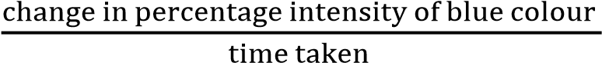
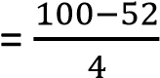
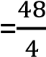
Rate of respiration = 12%per minute
Hence the average rate of respiration of yeast in glucose solution during the first four minutes is 12% per minute
  - Describe the change in the intensity of blue color with time, for each carbohydrate. (05marks)

    - Initially, the percentage intensity of blue colour is 100% for all carbohydrates.
    - Lactose:The percentage intensity of blue colour remains the same throughout the
time of the experiment.
    - Sucrose: The percentage intensity of blue decreases gradually and linearly with time
    - Glucose:The percentage intensity of blue colour decreases rapidly up to the 8th minute. It then decreases gradually up to the 18th minute after which it remains more or less constant up to the end of the experiment.
  - Explain the relationship described in (b) for each carbohydrate,
    - Lactose (03marks)
Lactose is not a substrate of yeast metabolism and therefore is not utilized throughout the experiment. This may be as a result of lack of enzyme, lactase, in the yeast cells to hydrolyze lactose into glucose and galactose.
Hence, As a result, the pH of the contents of the reaction medium remains the same throughout the experiment.

    - Sucrose

Sucrose is readily hydrolyzed into glucose and fructose by the enzyme, invertase, present in yeast. Glucose then undergoes anaerobic respiration to produce alcohol and carbon dioxide is an acidic gas and therefore lowers the pH of the contents of the boiling tube and so reduces the percentage of the intensity of the blue colour.
Sucrose acts as a ready stock of glucose which is increasingly broken down to provide glucose for respiration of the yeast cells. As a result, increasingly more carbon dioxide is produced, thereby progressively increasing the acidity of the medium and therefore reducing the percentage intensity of the blue colour continually.

    - glucose

Initially, the concentration of glucose is high. This is utilized directly by the yeast cells, respiring anaerobically to produce carbon dioxide and alcohol. Since the glucose is readily available, the rate of production of carbon dioxide is higher for glucose than sucrose and therefore reduces the percentage intensity of the blue colour more rapidly with time.
Decreasing rate of reduction in percentage intensity of the blue colour occurs because;
      - The amount of glucose remaining in the boiling tube has greatly reduced.
      - The yeast cells have started to be inhibited/ killed by the accumulation of ethanol in the reaction medium.
As a result, the rate of respiration decreases progressively at a decreasing rate until equilibrium is attained and it remains constant.
  - Suggest what would happen to the color for glucose and sucrose if the experiment continued for 10 more minutes. Give an explanation in each case (10marks)

The colour for glucose would remain the same throughout the extra 10 minutes.
    - This is because the yeast cells are inhibited by the accumulation of ethanol so that further respiration of the available glucose, if any, does not continue. Therefore, the pH of the medium remains the same for the entire extra 10
The colour for sucrose would eventually reduce in intensity at a decreasing rate until it becomes constant.
    - This is because sucrose would continue to decrease in the medium until it is depleted
    - Also, the accumulation of alcohol in the medium would eventually inhibit the action of the enzymes of the yeast cells.

  - Explain why the boiling tubes were
    - Kept covered during the experiment. (03marks)

        - to prevent the escape of the carbon dioxide produced during process of yeast reparation.
        - To prevent entry of oxygen into the reaction medium. This would lead to rapid aerobic breakdown of the food substrates
    - Placed in a water bath at 30⁰C. (3marks)

- – to maintain the temperature at a value optimum for the functioning of the yeast enzymes. This is important in order to ensure that only the investigated variables are investigated.

TOPIC 5: Homeostasis
Competency: The learner evaluates the regulation and maintenance of optimal internal environment in living organisms by analyzing how organ systems generate and eliminate metabolic wastes and maintain the functioning of cells, to make life choices that promote wellness.

Contents
Homeostasis: ................................................................................................................................................. 3
Why homeostasis is necessary/significance of homeostasis .................................................................... 3
Mechanism of homeostasis ...................................................................................................................... 3
Components of an efficient homeostatic system ..................................................................................... 3
Examples useful positive mechanism processes ...................................................................................... 4
The homeostatic control of glucose ............................................................................................................. 4
The role of the pancreas in regulation of glucose .................................................................................... 5
Diabetes mellitus is a disease condition cause by inability of an individual’s pancreas to produce
enough insulin. ...................................................................................................................................... 6
Diabetes mellitus .................................................................................................................................. 6
Cells that secrete insulin and glycogen: .................................................................................................... 6
Temperature regulation in Man ................................................................................................................... 7
How heat energy is lost or gained the body. ............................................................................................ 7
The skin ..................................................................................................................................................... 8
Response of man (endotherms) to cold conditions .................................................................................. 9
Behavioural mechanism animals to cold conditions ................................................................................ 9
Response of human body to hot conditions. ........................................................................................ 9 Adaptations of endotherms to cold environment. ................................................................................. 10 Adaptations of endotherms to hot environment. .................................................................................. 10
Behavioural control of body temperature by ectoderms ....................................................................... 10
Adaptations of animals to live in cold environment ............................................................................... 10
The brain and temperature regulation ................................................................................................... 11
The upper and lower critical temperature of the body .......................................................................... 11
Temperature control in plants ................................................................................................................ 13
Water regulation/osmoregulation in man .................................................................................................. 13
Key components of the of osmoregulation system ................................................................................ 13
The brain and thirst mechanism ......................................................................................................... 13
The kidneys and ADH .......................................................................................................................... 13
The renin-angiotensin-aldosterone system (RAAS) ............................................................................ 14
Water regulation in plants: ..................................................................................................................... 15
Adaption of xerophytes to drought .................................................................................................... 15
Morphological adaptations (Structure) in relation to water control ...................................................... 16
Revision exercise on homeostasis .............................................................................................................. 18
Revision Question on temperature regulation ........................................................................................... 26

Homeostasis:
The term homeostasis (from a Greek word meaning staying the same) is used to mean maintenance of static or constant conditions in the internal environment of the body. It describes all mechanisms by which a constant environment is maintained in the body.

Why homeostasis is necessary/significance of homeostasis
Homeostasis is crucial for the survival of all living organisms, as it allows them to maintain a stable, functional internal environment despite constant changes in the external world. The body has to keep proper concentration of oxygen, glucose, osmotic pressure, temperature, pH, the different electrolytes such as potassium and sodium and other nutrients. Without this dynamic balance, cells, tissues, and organs cannot function properly, leading to disease and, ultimately, death

Mechanism of homeostasis
1. Negative Feedback: is a mechanism whereby deviation from a set norm causes a corrective mechanism to restores the norm. For example, increase in the concentration of glucose in blood initiates mechanism that brings the concentration back to normal.

An efficient negative feedback mechanism is the one that detects small changes from the norm and responds fast to prevents big fluctuations from the set point

Components of an efficient homeostatic system
An efficient homeostatic system possesses several key characteristics that allow an organism to maintain a stable internal environment:
- Sensitivity/Detection: The system can detect even slight deviations of a variable (e.g., temperature, pH, glucose levels) from its specific set point.
- Rapid Response: Effectors act promptly to counteract deviations and restore balance quickly.
- Precision of Control: The system makes corrections that return the variable precisely to its optimal range, avoiding large overshoots or fluctuations.
- Specificity: Each receptor and effector is specialized to respond to particular stimuli, preventing cross-interference between different regulatory processes.
- Negative Feedback: The primary mechanism of control is negative feedback, where the response reduces the original stimulus, bringing the variable back towards the set point.
- Integration and Coordination: A central processing center (e.g., the brain's hypothalamus) integrates signals from multiple sources and coordinates the actions of various effectors to produce a unified, effective response.
- Adaptability (Plasticity): The system can adjust its set points and sensitivities in response to changing environmental demands or developmental stages (a concept sometimes called allostasis or rheostasis).
- Redundancy: Multiple, overlapping mechanisms often regulate the same variable. This ensures that the failure of one component does not lead to a complete system failure.
- Energy Efficiency: The system maintains stability with minimal unnecessary expenditure of energy and resources.
- Dynamic Stability: Homeostasis is not a static condition but a dynamic process involving continuous, active adjustments around a set point to achieve active stability.
2. Positive feedback: is a mechanism whereby the deviation from the norm causes further deviation. When a person is caught up in in a burning building, high temperature increases the activity of enzymes which result into further heat production. Positive feedback mechanism leads to death.

Examples useful positive mechanism processes
- Child birth
During labour release of oxytocin intensifies and speeds up contraction. The increase I contraction causes more oxytocin to be released and the cycle goes on until the baby is born.
- Blood clotting
Once a vessel is damaged, platelets start to cling to injured site release chemicals that attract more platelets. The platelets continue to pile up and release chemical until a clot is formed.

The homeostatic control of glucose
The normal concentration of glucose in human blood is approximately 90mg per 100 cm³, and even after the heaviest carbohydrate meal rarely exceeds 150mg per 100cm³. After absorption from the gut various things can happen to glucose in the body.
- It is broken down into carbon dioxide and water, particularly in active tissues such as the muscles.
- It may be built into glycogen and stored.
- It may be converted into fats and stored in the body’s fat depots.
- If glucose is in short supply, glycogen may be broken down into glucose.

The concentration of glucose in the blood and tissue fluids at any moment is determined by the relative extent to which these different processes occur in the body. For example, if there is too much glucose, as after a large meal rich in carbohydrates, the cells convert the surplus glucose, the liver cells convert glycogen lowering its concentration in blood. When the concentration of glucose is lowered in blood, the liver cells convert glycogen into glucose, thereby raising the glucose concentration in the body.
In prolonged deficiency, glucose may be formed from non-carbohydrate source, including fat and proteins. This is called gluconeogenesis. This explains the wasting away of tissues, which occur in extreme starvation. This is because the body resort to converting its tissue proteins into carbohydrates.

The role of the pancreas in regulation of glucose
High concentration of glucose in blood triggers the pancreas to secrete the hormone insulin from β-cells of islets of Langerhans. This insulin exerts its effect lowering the blood glucose level mainly by
- increasing the conversion of glucose to glycogen and fat by the liver cells.
- inhibits the formation of glucose from glycogen and non-carbohydrate sources (gluconeogenesis).
- Increasing oxidation of glucose into carbon dioxide and water.

Low concentration of glucose in blood triggers the pancreas to secrete the hormone glucagon from α-cells of islets of Langerhans and inhibits secretion of insulin. This increases the concentration of glucose by
- Causes liver cells to convert glycogen and fat by the liver cells.
- Promotes gluconeogenesis or the formation of glucose from glycogen and noncarbohydrate sources

The homeostatic scheme of control of glucose in mammalian body is shown below

Pancreas secretes
insulin and
Blood glucoseless glucagon Liver cells
concentration convert glucose
rises to glycogen
Correct glucose Correct glucose concentration concentration

Liver cells
Blood glucose Pancreas convert glycogen concentration secretesto glucose ^{falls} glucagon and

less insulin
Diabetes mellitus is a disease condition cause by inability of an individual’s pancreas to produce enough insulin.
It is characterized by increased in the blood glucose concentration (hyperglycaemia), and glucose appears in urine (glycosuria). The production of urine increases and the patient may suffer from intense thirst. Later symptoms include severe loss of the body mass, muscular waste and skin lesions. If untreated the patient goes into a diabetic coma and dies.
Diabetes mellitus is controlled by appropriate doses of parenteral insulin.
A sub-normal glucose concentration is called hypoglycaemia. If this is uncorrected, it causes a person to go into coma. Hypoglycaemia is particularly liable to occur during fasting, and one of glucagon’s main functions is to counteract this.

Cells that secrete insulin and glycogen:
By suitable staining techniques of islets of Langerhans two types of secretory cells can be distinguished in the islets: alpha cells and beta cells figure below: Microscopic microgram of cells that produce insulin and glucagon
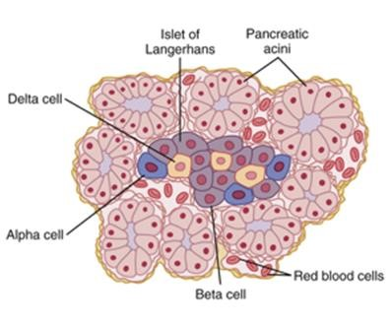

The alpha cells located in the peripheral part of the islet, secret glucagon, whereas the more centrally placed beta cells secrete insulin. Both hormones are secreted into blood capillaries within the islet; from which they pass into the general circulation to control the secretion of insulin.

Temperature regulation in Man
The human body temperature must be kept constant because enzymes work best at 36.9⁰C - optimum temperature. At high temperature above 40⁰C enzymes are denatured or too low temperatures lead to slowing of metabolic activities and impairing the activities of important organs such as the brain.
How heat energy is lost or gained the body.
Organisms loss or gain heat from the environment by four physical processes.
- Conduction in the transfer of heat energy from hotter to the cooler of two objects in contact with each other.
- Radiation is the heat transfer from a hot body to a cool one that are not in contact. It is a major source of heat loss.
- Evaporation is change of a liquid to a vapour, it is accompanied by cooling. This is the cause of cooling accompanied by sweating.
- Convection: is the movement of air resulting from local pockets of warm air being replaced by cooler air, and vice vasa. There air movement speeds up loss of heat by radiation and evaporation.
In addition animals may loss heat through
- Urinating warm urine
- Vomiting
- Spitting
- Defaecating

The skin

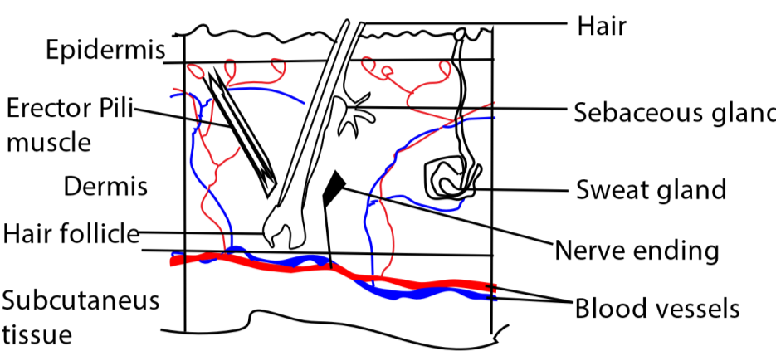

The skin is divided into two main layers, the epidermis at the surface, and the dermis beneath. Below the dermis is another layer, not strictly part of the skin, called the hypodermis.
The epidermis is made up of stratified epithelium. The bottom-most layer of cells, the Malpighian layer, contains variable amounts of black pigments melanin which protects the body from the harmful effects of ultraviolet rays from the sun.
The cells of the Malpighian layer divide repeatedly in a plane horizontal to the surface of the body. As new cells are formed, the older ones get pushed outwards towards the surface, flattening as they do so. After a time, the cytoplasm become converted into scales of Keratin, giving rise to Keratinised layer at the surface of the epidermis. The keratinised layer protects the skin from damage and makes it water proof.
Oil is secreted on to the surface of the epidermis by sebaceous glands makes the hair supple and enhances the skin’s water proofing properties.
The roots of the hair are embedded in the dermis or hypodermis. Running from the side of each hair follicle to the base of the epidermis is erector pili muscle. When this muscle contracts, the hair is pulled into a more vertical position. In this position hair trap a layer of air around the skin thereby insulating the skin from heat loss.
The dermis contains sweat glands which secrete a salty solution, sweat. The sweat passes down the sweat ducts to the surface of the epidermis, and its subsequent evaporation cools the skin and blood flowing through it.
The hypodermis contains variable amount of fat (subcutaneous fat) which insulate and prevent heat loss from the body.

Response of man (endotherms) to cold conditions
- The hair is raised and brought into a more-or- less vertical position by contraction of erector pili muscle. Air gets trapped in the spaces between the hairs and being a poor conductor of heat, it serves as an insulator round the animals. In humans the body hair is much reduced, its placed being taken by clothes. Even so the erector pili muscles contract just the same, resulting in “goose pimple”. In birds the feathers serve the same function as the hair of mammals, being raised in cold weather.
- Vasoconstriction: i.e. the arterioles leading to the superficial capillaries constrict. As a result, the blood flow to the surface of the skin is reduced, thereby cutting down the heat energy from the blood to the surrounding.
- The metabolic rate increases, the generation of heat inside the body to compensate for heat loss.
- Decrease in sweating reduce heat loss through evaporation.
- Shivering: at very low temperature skeletal muscles are stimulated to contract and relax automatically leading to production of heat.

Behavioural mechanism animals to cold conditions
- Engaging in exercises (making a lot of noise in some organism)
- Taking hot drink or bath
- Wearing heavy clothes
- Burrowing
- Hibernation
Response of human body to hot conditions.
- The hairs are lowered: by relaxation of erector pili muscles, so they lie flat against the surface of the skin, less air is trapped between the hairs, insulation is therefore reduced, and heat energy can be lost more readily by conduction, radiation and convection.
- The arterioles leading to the superficial capillaries dilate. As a result, the blood flow to the surface is increased and more heat energy can be lost to the surrounding.
- Sweating or panting occur, and evaporation of water from the moist skin or tongue cools the blood as it flows through the superficial capillaries. As a means of cooling the human body sweating is extremely important. In dogs and cats sweating is substituted with panting.
- The metabolic rate decreases, reducing heat energy generated in the body.
Adaptations of endotherms to cold environment.
- The animals develop large volume to surface ratio. i.e. the extremities such as ear tend to be small and the animals tend to be larger.
- Animals in cold environment have thicker subcutaneous fat.
- Animal in cold environment tend to have heavy fur or hairs.
- Animals in cold environment develop high metabolic rates.
- Reduced extremities to reduce the surface area for heat loss.
- Animals in cold environment develop arteries and veins in close proximity, such that as blood flows down the arteries, heat energy passes from it to the much cooler blood which is returning in the opposite direction in the veins. The counter current heat exchange system is seen in flippers of dolphins and the legs of ducks, both of which are highly happen to be in cold water. It achieves two things. First it means that the arterial blood has already been cooled by the time it reaches the end of the limb, so that relatively little heat energy is lost to the surrounding. Secondly it warms the venous blood before it gets back to the main part of the body.
Adaptations of endotherms to hot environment.
  - Have thin subcutaneous fat layer to promote heat loss
  - Are small compared to their counterpart in cold region to provide bigger surface area to volume ratio
  - Have large extremities to increase the surface area for heat loss.
  - They have many sweat glands to produce sweat whose evaporation cools the body e. Have less fur

Behavioural control of body temperature by ectoderms
Many ectoderms respond to high environmental temperature by
- Moving to cool places
- Thermal gaping
- Aestivation
- Migration to cooler places
Ectoderms respond to cool environment temperatures by
- Moving to warm place
- Basking
- Sleeping in piles to reduce heat loss
- Burrowing

Adaptations of animals to live in cold environment
- Hibernating is a behavioural response by many temperature and artic animals to very cold temperature. The animal responds to very cold temperature by going into a deep sleep. The metabolic rate falls to the minimum required to keep life ticking over. The body temperature also falls, and is maintained at a much lower level than normal. Hibernation saves these animal of expending large heat energy in winter whilst the food is scarce surviving extremes of temperatures.
- By super cooling: Super cooling is the lowering of the temperature of a fluid to below its freezing point without the formation of ice. Ice crystals can damage tissues and super cooling provides a way of avoiding this. Experiments have shown that certain reptiles can be super cooled to as low as -8⁰C without freezing. Plants and fishes also go in for super cooling.
- By freezing tolerance. Some organisms, notably plants and insects can tolerate the formation of ice in their tissues. Certain insects’ larvae can recover after as much as 90% of the body has been frozen. In these organism’s ice crystals form between, rather than inside the cells; later when the ice melts. In some species of fish ice damage is lessened by the presence of glycol in the tissues. glycerol is used in human blood banks and sperm banks to prevent injury to the cells when they are frozen for storage.
- By using an antifreeze: some fish employ anti-freeze such as glycerol and glyco-protein to lowers the freezing point so that the body fluids do not freeze in winter.

What about high temperatures?
The main adaptation here is tolerance. This enables certain types of algae to flourish in hot springs at temperatures of 55 to 60⁰C. However, it is prokaryotes that show the greatest tolerance. There are many reports of bacteria growing in boiling hot springs to North America and New Zealand, but the jackpot must go to certain bacteria which have been discovered in the hot water rising from sulphate encrusted vents in the deep ocean floor. Some of these bacteria were living at temperatures of 350⁰C. It is claimed that in the laboratory they reproduced enthusiastically in sea water at 250⁰C, doubling in number every 40 minutes. Heat tolerant bacteria possess membranes which are more heat stable than those of other prokaryotes, and their enzymes work optimally at temperatures well above those that would denature the enzymes of other organism. e.g. Thermophilus, a bacteria which lives in hot springs, possesses enzymes that work best at 80⁰C.

The brain and temperature regulation
Thermoregulation centre in the brain is found in hypothalamus. Hypothalamus is sensitive to the temperature of blood flowing through it and responds by sending nerve impulses to the appropriate effector. If the temperature of blood is higher than normal, the thermos regulatory centre detects this and sets into motion the various processes that cool the body and the vice versa.

The upper and lower critical temperature of the body
- The lower critical temperature.
The lower critical temperature is the environment temperature below which physical mechanism such as insulation cannot maintain body temperature. The lower critical temperatures are lower for arctic mammals (e.g. Eskimo dog, white fox) than for tropical mammals such as man
The lower critical temperature for arctic mammal is about -40⁰C while that of man is 27⁰C. When the animal is cooled below the lower critical temperature, the basal metabolic rate increases to maintain the body temperature until the temperature reaches the lower lethal temperature below which the organism dies for failure to maintain body temperature.

Artic mammals have lower critical and lethal temperature due big layer of subcutaneous fats and thick fur for insulation; they have small extremities and their arteries and veins from extremities are close to each other to reduce heat loss.

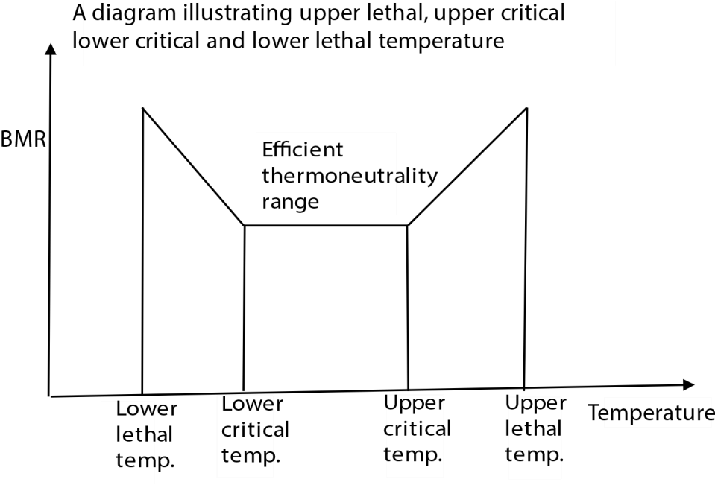

- The Upper critical temperature.
The upper critical temperature (29⁰C for man) is the environment temperature above which physical mechanism such as sweating, lowering hair cannot maintain body temperature. The upper critical temperatures are lower for arctic mammals (e.g. Eskimo dog, white fox) than for tropical mammals such as man

When the environmental temperature rises above the upper critical temperature, the basal metabolic rate increases due to increase in body temperature and enzymatic controlled reaction up to the upper lethal temperature above which enzymes are denatured and the organism dies.

Desert animal have higher critical and lethal temperatures than artic animals because the have low fat deposits and less hair to insulate the body

Temperature control in plants
- Transpiration lowers escalating temperature.
- Shiny cuticles reflect heat radiated by the sun.
- Having small leaves reduce surface area for heat absorption.

Water regulation/osmoregulation in man
Water regulation in man, or osmoregulation, is a complex homeostatic process that maintains the proper balance of water and solutes in the body. It relies on coordinated responses between the brain, kidneys, and endocrine system, involving hormone signaling and a negative feedback loop to ensure fluid balance despite varying intake and environmental conditions.

Key components of the of osmoregulation system
The two main parts of the water regulation system are the brain, which senses fluid changes and triggers responses, and the kidneys, which adjust water excretion accordingly.

The brain and thirst mechanism
The hypothalamus contains osmoreceptors, specialized neurons that monitor the osmotic concentration of the blood. When blood becomes too concentrated (high osmolality), water moves out of the osmoreceptor cells, causing them to shrink. This sends a signal to the hypothalamus.
In response to the signal, the hypothalamus triggers the conscious sensation of thirst, prompting the person to drink water. It also directs the pituitary gland to release the hormone antidiuretic hormone (ADH), also known as vasopressin.

The kidneys and ADH
When blood becomes too concentrated (high osmolality) ADH is released from pituitary gland and travels through the bloodstream to the kidneys; here it increases the permeability of the collecting ducts to water by causing the insertion of water channels called aquaporins into their cell membranes. With more aquaporins available, more water is reabsorbed from the urine back into the bloodstream, producing a smaller volume of more concentrated urine.
If blood osmolality is low, the production of ADH is suppressed. The aquaporin channels are removed, and the collecting ducts become less permeable to water. As a result, more water is excreted as a large volume of dilute urine.

The renin-angiotensin-aldosterone system (RAAS)
In addition to ADH, the RAAS helps regulate water balance, primarily in response to low blood volume and pressure, which often accompanies severe dehydration.
- The kidneys release the enzyme renin when they detect decreased blood volume.
- Renin activates the production of angiotensin II, a potent hormone that affects multiple organs.
- RAAS effects: Angiotensin II contributes to water retention in several ways:
  - It stimulates the release of aldosterone from the adrenal glands, which promotes the reabsorption of sodium and, consequently, water in the kidneys.
  - It further stimulates the release of ADH. o It directly promotes thirst.
  - It constricts blood vessels to increase blood pressure.

The negative feedback loop
The entire process operates as a negative feedback loop that maintains the body's hydration levels within a narrow range.
- Stimulus: Dehydration (low water, high solutes) increases blood osmolality.
- Sensory input: Osmoreceptors in the hypothalamus detect this change.
- Response: The hypothalamus triggers thirst and signals the pituitary gland to release ADH.
- Effector: ADH acts on the kidneys to increase water reabsorption.
- Outcome: Drinking water and retaining it through the kidneys decreases blood osmolality, bringing it back to normal levels.
- Inhibition: This return to normal inhibits the release of ADH and the sensation of thirst, completing the feedback loop.
Inability of a person to produce insufficient amounts ADH causes diuresis; the disease condition is called diabetes insipidus.
Water regulation in plants:
Plants can be classified into three groups according to how much water is available to them in their nature environment.
- Hydrophytes: are plants which live partially or completely submerged in fresh water. e.g.
water lilies, obviously, such plants have no difficulty getting enough water. Hydrophytes have the following adaptations to get rid of excess water
  - Poorly developed root system to reduce water absorption.
  - Numerous stomata on the upper epidermis of the leaf to increase water loss.
  - Have leaves lack cuticle to promote water loss
  - Have poorly developed xylem to reduced water transported in plant - Broad thin leaves to promote water loss.
- Mesophytes: grow in normal, well - watered soil. Most land plants in temperate regions belong to this category. Usually the water which they lose by transpiration is readily replaced by uptake from the soil, so they require no special means of conserving water.
- Xerophytes: live in dry places such as the hot desert where the water potentials in the soil and air are very low. These plants face the possibility of drastic dehydration and have ways of preventing this.

Adaption of xerophytes to drought
Xerophytes, plants adapted to dry or arid conditions, have evolved a variety of structural (morphological) and physiological adaptations to conserve water, reduce water loss, and maximize water absorption. These adaptations allow them to thrive in environments with low water availability, high temperatures, and intense sunlight, such as deserts and semi-arid regions.

Morphological adaptations (Structure) in relation to water control
Leaves
- Reduced surface area: Many xerophytes have smaller leaves, or leaves that are modified into needle-like structures or spines, as seen in cacti. A smaller surface area reduces the number of stomata and minimizes water loss through transpiration.
- Spines: In addition to reducing water loss, the sharp spines of cacti deter herbivores from eating the water-rich plant.
- Thick, waxy cuticle: A thick, impermeable, waxy layer on the surface of leaves acts as a barrier to evaporation, significantly reducing cuticular water loss. The shiny surface also reflects sunlight, which lowers the leaf temperature and further reduces evaporation.
- Hairy or silvery leaves: Some xerophytes have a dense covering of fine hairs, or a silvery color, on their leaf surfaces. These hairs reduce airflow over the leaf surface, trap a layer of humid air, and reflect sunlight to minimize heat absorption.
- Rolled leaves: In some grasses, like marram grass, the leaves can roll inwards during drought. This encloses the stomata in a humid space, significantly reducing the outward water potential gradient and slowing transpiration.
- Sunken stomata: The stomata (pores for gas exchange) are located in pits or grooves on the leaf surface, often in depressions lined with hairs. This traps moist air around the stomata and reduces air movement, minimizing water loss.

Stems
- Succulent stems: Cacti and other succulent xerophytes have fleshy stems that are specialized for storing large quantities of water. These swollen stems can expand and contract to accommodate the water storage.
- Photosynthetic stems: With leaves often reduced or absent, the stems of many xerophytes become green and take over the role of photosynthesis.
- Protective coatings: Stems may be covered with thick wax or dense hairs, similar to leaves, to further minimize water loss.

Roots
- Deep taproots: Larger xerophytic plants, like mesquite or acacia trees, have very deep root systems (sometimes hundreds of feet long) to access groundwater stored deep underground.
- Extensive shallow roots: Many cacti and other desert plants have a wide-spreading, but shallow, fibrous root network. This allows them to quickly absorb any moisture from infrequent, light rainfall before it can evaporate.

Physiological adaptations (Function)
- Crassulacean Acid Metabolism (CAM): Many succulents, including cacti and agaves, use a specialized photosynthetic pathway known as CAM. They open their stomata at night, when temperatures are cooler and humidity is higher, to take in and store carbon dioxide. They then close their stomata during the day to minimize water loss while still performing photosynthesis.
- Nocturnal stomatal opening: Even without full CAM metabolism, some xerophytes open their stomata at night to reduce water loss, as the night air is cooler and more humid.
- Osmotic adjustment: Xerophytes can accumulate solutes, like sugars and salts, in their cells. This increases the internal osmotic pressure, allowing the plant to maintain cellular turgor and draw water in, even when soil water potential is low.
- Drought deciduousness: Some xerophytes, such as the ocotillo, can shed their leaves during prolonged dry spells to significantly reduce transpiration. When rain returns, new leaves are produced.
- Dormancy and resurrection: Certain "resurrection plants" can effectively shut down their metabolism and endure extreme desiccation. They appear dead until they are rehydrated, at which point they quickly return to life.
Life cycle adaptation.
Most species can survive dry periods in the dormant stages e.g. desert ephemerals. Germination, growth and flowering takes place during a few weeks following a burst of rain, after the seeds have been dispersed, the parent plant die and the seeds remain dormant in the dry soil until the next rains come.

Revision exercise on homeostasis
- An efficient physiological homeostatic mechanism is one which
  - Allow large fluctuation
  - Responds to deficiency faster than excess
  - Responds to small fluctuation
  - Allow positive feedback C
- Which one of the following pairs of hormones when released increase the level of blood sugar in the body?
  - Secretin and insulin
  - Adrenalin and glucagon
  - Insulin and antidiuretic hormone
  - Secretin and thyroxine B
- Which of the following is not involved in a physiological homeostatic process?
  - Positive feedback mechanism
  - Receptor
  - Effector
  - Control mechanism A
* Positive feedback amplifies change. Homeostasis is the process of maintaining a stable internal environment by counteracting changes to return to a set point. A positive feedback mechanism, by contrast, amplifies a change or a stimulus, moving the system further away from its initial state.
- Which of the following is not homeostatically regulated in the body?
  - Glucose
  - Water
  - Carbon dioxide
  - Fat D

- Which one of the following is not a requirement for the working of a physiological homeostatic mechanism? A. Receptors.
  - Skin capillaries.
  - Control mechanisms.
  - Effectors. B
* Core components of homeostasis: A homeostatic mechanism requires three fundamental components:
  - A receptor (or sensor) to detect changes in a variable (e.g., body temperature, blood glucose).
  - A control mechanism (or integrating center) to process the information from the receptor and determine the appropriate response.
  - An effector to carry out the response and restore the variable to its set point.
  - Skin capillaries are a specific effector. Skin capillaries are part of the circulatory system and are effectors primarily involved in thermoregulation. While they are crucial for maintaining body temperature homeostasis, they are not a universal component required for all homeostatic processes, such as blood sugar regulation or osmoregulation.
- The islets of Langerhans in the pancreas secretes hormones important for regulation of
  - carbon dioxide in blood
  - blood protein
  - blood sugar
  - insulin C

* Insulin and Glucagon: The islets of Langerhans contain specific cells that produce hormones crucial for blood sugar (glucose) regulation.
    - Beta (𝛽) cells secrete insulin, which lowers blood sugar levels after a meal by encouraging cells to take up glucose.
    - Alpha (𝛼) cells secrete glucagon, which raises blood sugar levels between meals by promoting the breakdown of glycogen in the liver into glucose.

Section B
- (a) (i) What is meant by negative feed feedback in homeostasis? (2marks) Negative feedback is a control system that reverses a deviation from a set point
(b) Give two charateristics of an efficient homeostatic system (2marks)
An efficient homeostatic system possesses several key characteristics that allow an organism to maintain a stable internal environment:
    - Sensitivity/Detection: The system can detect even slight deviations of a variable (e.g., temperature, pH, glucose levels) from its specific set point.
    - Rapid Response: Effectors act promptly to counteract deviations and restore balance quickly.
    - Precision of Control: The system makes corrections that return the variable precisely to its optimal range, avoiding large overshoots or fluctuations.
    - Specificity: Each receptor and effector is specialized to respond to particular stimuli, preventing cross-interference between different regulatory processes.
    - Negative Feedback: The primary mechanism of control is negative feedback, where the response reduces the original stimulus, bringing the variable back towards the set point.
    - Integration and Coordination: A central processing center (e.g., the brain's hypothalamus) integrates signals from multiple sources and coordinates the actions of various effectors to produce a unified, effective response.
    - Adaptability (Plasticity): The system can adjust its set points and sensitivities in response to changing environmental demands or developmental stages (a concept sometimes called allostasis or rheostasis).
    - Redundancy: Multiple, overlapping mechanisms often regulate the same variable. This ensures that the failure of one component does not lead to a complete system failure.
    - Energy Efficiency: The system maintains stability with minimal unnecessary expenditure of energy and resources.
    - Dynamic Stability: Homeostasis is not a static condition but a dynamic process involving continuous, active adjustments around a set point to achieve active stability.
- (a) Outline the general feature a physiological homeostatic system must have. (3marks)
  - Receptor mechanism capable of detecting changes in the environment
  - Control mechanism that initiates corrective mechanism
  - Effector that carry out the corrective mechanism
(b) What are the qualities of an efficient homeostatic system) (2marks)
Ref to 7(b)
9. (a) Figure 1 shows the average blood glucose levels in the three major vessels of the liver of an individual, who had meals at 7.00 am and 1.00pm. use the information to answer the questions that follow

.

Compare the levels of glucose in:

am
8.00
a
10.00
m 12.00
p
2.00

pm
4.00

350
300
200
100
Concentration
(
mg/100cm
3
)

Hepatic portal vein

Hepatic vein

Hepatic artery
Figure 1

noon

(i) Hepatic artery and hepatic vein (4mrks)

Similarities.
  - In both, blood glucose level increases after a meal, reaching maximum within 2 hours of having a meal.
  - In each, the blood glucose levels decrease gradually between 10: 00an and 12:00 noon.
  - In both, blood glucose levels decrease after about 2 hours of having meals.
Differences.
Hepatic artery | Hepatic vein
lower glucose level throughout the experiment | higher glucose level throughout the  experiment
Reaches a lower maximum after each meal | Reaches a higher maximum value after each meal.
Between 9:00am and 4:00pm glucose level is lower | Between 10:00am and 1:00pm glucose level is higher.
(ii) Hepatic artery and hepatic portal vein (4marks)

Similarities.
  - In both, blood glucose level increases after a meal, reaching maximum within 2 hours of having a meal.
  - In each, the blood glucose levels remain fairly constant between 10: 00an and 12:00 noon. o In both, blood glucose levels decrease after about 2 hours of having meals.
Differences.
Hepatic artery | Hepatic portal vein
- Higher glucose level initially.  - Increases more gradually after a meal.  - Reaches a lower maximum after each meal.  - Decreases gradually after about 2 hours of having meal.  - Between 10:00an and 1:00pm glucose level is higher. | - Lower glucose level initially.  - Increases more rapidly after a meal.  - Reaches a higher maximum value after each meal.  - Decreases rapidly after about 2 hours of having a meal.  - Between 10:00am and 1:00pm glucose level is lower.

(i) Explain the differences in the level of glucose in the
  - Hepatic artery and hepatic vein (9marks)

The blood glucose in hepatic vein is slightly higher because it is close to the source (intestines) but the difference in glucose level in both hepatic vein and hepatic artery is slight because in both glucose is under homeostatic control.
  - Hepartic artery and hepatic portal vein (9marks)
After meals the glucose level the glucose level in hepatic portal vein shoots up due to absorption from the intestines but later falls due to homeostatic mechanisms.

(b) The figure shows the blood levels in a normal and diabetic individual, after both individual were gives a sugar solution at 7.00 a.m. Study and answer the questions that follow (11marks)
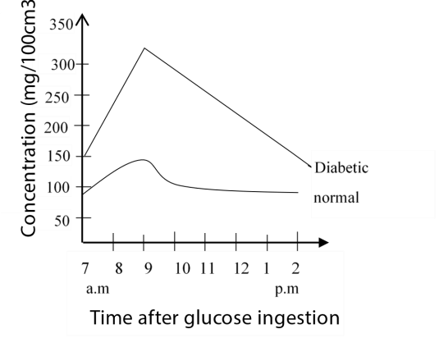

- Compare the levels of glucose between the two individuals (5marks) Similarities.
  - In both, blood glucose levels are above zero at 7:00am.
  - In both, blood glucose levels increase after being given the sugar solution to a maximum value and then decrease.
Differences

Diabetic

Normal

-

Higher glucose level at

all times.

-

Glucose level increases rapidly after
the sugar meal and reaches a higher
maximum in about 2 hours.

-

Decreases
rapidly

after about 2
hours and never attains a constant
value.

-

Lower glucose levels at all times.

-

Glucose level increases gradually

after
the sugar meal and reaches a lower
maximum in about 1 ½ hours.

-

Decreases gradually after about 1 ½
hours and attains a constant value within
about 3 hours.

- Give explanation for the observed pattern of the levels of blood glucose in the two individuals (5marks)

      - both individuals have blood glucose levels above 0mg/100cm³ initially because glucose has to be in the circulation of sustain metabolic functions.
      - Increase in the glucose concentration after the sugar meal in both individuals is due to the direct absorption of glucose into the blood stream from the alimentary canal however, that of a normal individual increases gradually because the blood sugar level is more under homeostatic control than in a diabetic individual.
      - In a normal individual, an increase in the blood glucose level as a result of the sugar meal stimulates the Islets of Langerhans in the pancreas to secrete the hormone insulin. Insulin acts on the cells of the liver, muscles and adipose tissue to reduce the blood sugar level.
      - A diabetic individual produces either none or insufficient amounts of insulin so that the homeostatic control of blood glucose is impaired. As a result, a diabetic individual always has higher blood glucose levels which always fluctuate and never attain a constant value as in the normal individuals.

- What is the significance of the physiological process illustrated in the figure 1 and 2

    - it ensures that the body cells are always continually supplied with the correct amount of glucose required for normal cell function.
    - It ensures that the blood contains the correct amount of glucose necessary for maintaining the correct osmotic pressure.
    - It indicates that the liver plays the key role in regulating the blood glucose levels.
    - It indicates that regulation of blood glucose level should occur quickly for the body organs to function normally.

10. (a) What is meant by negative feedback mechanism in the body process? (3mark)
Negative feedback is a control system that reverses a deviation from a set point

- Describe how each of the following affects the metabolism of carbohydrates (i) insulin (3marks)

    - it increases the rate of uptake of glucose by muscle and fat cells through a number of glucose channels in the cell surface membrane.
    - - Insulin increases the utilization of glucose by the cells in the process of respiration.
    - Insulin increases the rate at which glucose is converted to glycogen in the liver and muscle cells (glycogenesis).
    - Insulin inhibits the formation of glucose from non-carbohydrates sources in the liver (gluconeogenesis) and also inhibits the process of glycolysis.

(ii) adrenaline (3marks)

  - It increases the rate of conversation of glycogen to glucose. This increases the blood sugar content.
  - It increases the rate of production of glucose from non-carbohydrate sources in the liver.
  - It increases the rate of utilization in the muscle cells in the process of respiration
- Describe how hormones from the ovary and pituitary gland interacts to control the human menstruation cycle.
In this question, you are meant to identify the hormones produced by the ovary and pituitary gland during the menstrual cycle and illustrate how they interact to bring about the events of the menstrual cycle.
Hormones produced by the ovary include progeserone and oestrogen while the pituitary gland produces luteinizing hormones (LH) and follicle stimulating hormone (FSH) which interact as shown to control events of the menstrual cycle.
During the early menstrual phase, levels of oestrogen and progesterone fall. This induces the pituitary gland to secrete FSH and LH.
Increased levels of FSH stimulate one or more Graafian follicles to start growing. It also stimulates follicle cells to secrete oestrogen. The levels of oestrogen in blood increase gradually for a few days and reaches the peak on the 12th day of the cycle. High oestrongen concentration inhibits FSH secretion which induces increased production of LH within 12hrs.
The high LH causes ovulation with subsequent formation of corpus luteum.
During the post ovulatory phase, corpus luteum secretes progesterone. Progesterone acts on the uterine wall to promote cellular proliferation in preparation for implantation and also maintains corpus luteum.
High levels of progesterone and oestrogen inhibit the secretion of LH and FSH.
If fertilization occurs, the corpus luteum degenerates. Progesterone level reduces markedly and the uterine wall is shed in menstruation. This initiates events of the next cycle (i.e. this is day 1 of the next cycle).

Revision Question on temperature regulation
1. Which one of the following conditions is correct about ectoderms?
- Have cold blood which is warmed by the surrounding
- Regulate body temperature mainly by metabolic reactions
- Much of the heat in their bodies is gained from the surroundings.
- Lack means to regulate body temperature. C

Explanation
- Definition of ectotherms: Ectotherms are animals that rely on external sources of heat to regulate their body temperature.
- External heat sources: These animals use behaviors such as basking in the sun or lying on a warm rock to absorb heat from their environment to raise their body temperature. When they get too hot, they seek shade or water to cool down.
- The term "cold-blooded" is inaccurate because an ectotherm's body temperature can be quite warm when they are in a hot environment or after basking in the sun.

Why other options are incorrect
- A. Have cold blood which is warmed by the surrounding: The term "cold blood" is misleading, as an ectotherm's blood can be warm.
- B. Regulate body temperature mainly by metabolic reactions: This describes endotherms (warm-blooded animals), which use internal metabolic processes to generate heat.
- D. Lack means to regulate body temperature: Ectotherms do regulate their body temperature, but they do so primarily through behavioral strategies (like seeking sun or shade) and physiological adaptations, not through internal metabolic heat production.

- A mammal eats more food than a reptile of equivalent body weight because the mammal
  - Lives longer
  - Controls its body temperature
  - Egests more food
  - Does not s absorb heat from its surrounding B
*Mammals require a lot of food to provide energy to maintain body temperature by replacing heat losses.
- Which one of the following occurs in a mammal when its thermoregulation centre detects a lower temperature of blood than normal?
  - Shivering
  - Decreased metabolic rate
  - Flattening of body hair
  - Increased sweating A
Shivering: This involves rapid, involuntary contractions of skeletal muscles. This muscular activity requires significant energy (ATP) and generates heat as a byproduct, effectively raising the core body temperature.

- The main difference between endotherms and ectoderms is that ectoderms
  - Gain their body heat from internal sources
  - Gain less heat than endotherms
  - Gain the body heat from external sources
  - Are lower animals while endotherms are higher animals. C
- Desert mammals’ lower lethal temperature is higher than that of a mammal living in cold regions because a desert mammal has
  - Small extremities
  - Poor insulation mechanism
  - Thick fur
  - Small surface area: volume ratio B

Explanation
The "lower lethal temperature" is the environmental temperature below which a mammal can no longer produce enough metabolic heat to maintain a stable body temperature and dies of hypothermia.
- Desert Mammals: Animals in hot climates are adapted to dissipate heat efficiently. They typically have thinner fur/fat layers (poor insulation) and a higher surface areato-volume ratio (e.g., larger ears, longer limbs, smaller overall size according to Allen's and Bergmann's rules) to maximize heat loss. This poor insulation makes them less effective at conserving heat in cold conditions, so their lower lethal temperature is relatively high (they succumb to cold more quickly).
- Cold Region Mammals: Mammals in cold regions are adapted to conserve heat. They have thick fur or substantial fat layers (good insulation) and a low surface areato-volume ratio (smaller extremities, larger bodies). This excellent insulation allows them to withstand much colder temperatures, so their lower lethal temperature is very low (they can survive even in extremely cold conditions).
Therefore, a desert mammal has a higher lower lethal temperature because its adaptations (including poor insulation) favor heat dissipation rather than heat conservation.

6. Which one of the following is the reason for hibernation of a humming bird every night? A. Its metabolic rate is so high
- It is too cold
- It feeds on nectar from flowers which close at night
- Its relatively large surface area would lose too much heat A
Explanation
Hummingbirds are among the smallest endotherms (warm-blooded animals) and possess the highest metabolic rate of any animal when active. This extreme metabolism is necessary to power their rapid wing beats (up to 80 times per second) and hovering flight, requiring them to feed almost constantly during the day.
At night, or when food is scarce, they cannot feed, and their energy reserves (stored fat) would be depleted within a few hours if they maintained their normal metabolic rate. To survive the long period without food, they enter a hibernation-like state called torpor every night. During torpor, their metabolism slows dramatically (by as much as 95%), their body temperature and heart rate drop significantly, allowing them to conserve enough energy to survive until the next morning's first feeding.

Why D is wrong
Hummingbirds have a large surface area-to-volume ratio due to their small size, which does lead to rapid heat loss. This is an underlying physical challenge that contributes to their high metabolic demands and the need for torpor, but the immediate reason for entering torpor nightly is the necessity to conserve energy due to their extremely high metabolic rate and inability to feed.
- Which one of the following may happen when a mammal is subjected to severe cold?
  - The superficial blood vessels are dilated
  - The hair is lowered
  - Sweating or panting occur
  - The rate of metabolism increase D
- Heat loss is most efficiently reduced in body extremities of endotherms having
  - Veins and arteries parallel and close to each other
  - Thick fur
  - Thick subcutaneous layer
  - few sweat glands A

Explanation
This anatomical arrangement describes a countercurrent heat exchange system.
- How it works: Warm arterial blood flowing from the body's core to the extremity (e.g., a leg or flipper) runs parallel and in close proximity to the cooler venous blood returning from the extremity.
- Heat transfer: Heat is transferred by conduction from the warmer arterial blood to the cooler venous blood before the arterial blood reaches the end of the limb.
- Outcome: This pre-warms the returning venous blood and significantly cools the arterial blood before it reaches the surface, minimizing the heat lost to the cold environment. The heat is effectively "recycled" back into the body's core. This is the most efficient mechanism specifically for conserving heat in the extremities of endotherms living in cold climates, such as the legs of wading birds and the flippers of dolphins.

- Which of the following is a chemical mechanism of coping with cold environment in mammalian body?
  - Vasoconstriction
  - Shivering
  - Raising of body hair
  - Insulation by the subcutaneous fat B
- Temperate mammals such as polar bear have lower lethal temperatures than tropical ones. This is because of
  - Better insulation mechanisms in the tropical mammals
  - Body colour
  - Larger size in temperate mammals
  - Better insulation mechanism in temperate mammals D
- A mammal eats more food than a reptile of equivalent body weight because the mammal
    - lives longer.
    - controls its body temperature.
    - egests more food.
    - does not absorb heat from its surroundings. B
- Which of the following environmental factors has a direct effect on all organisms
  - Light
  - Humidity
  - Temperature
  - Rainfall C
*Temperature affects enzyme activity, at low temperature enzymes are inactive, at very high temperatures enzymes are denatured.

Paper 1 section B
- Figure below shows the variation of metabolic rate with environmental temperature in a mammal

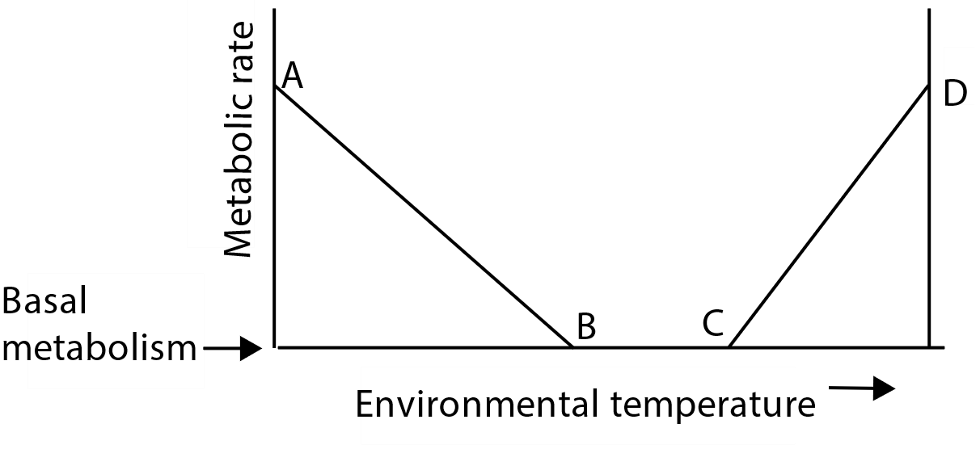
(a) What do points B and C represent?
(i) B: Lower critical temperature | (1mark)
(ii) C: upper critical temperature | (1mark)
- Explain why the metabolic rate
    - Is constant between points B and C (2mark)
Between B and C metabolic rate is constant because behavioural and physical means are enough to maintain body temperature.
    - Increases from point B to A (2marks)

B-A metabolic rate increases to generate heat for maintenance of body temperature

(iii) Increases from C to D (3marks)

C to D metabolic rate increases because increase in temperature increases the rate of enzyme action
- Explain how point B would differ between an animal living in cold regions and that living in warm region. (02marks)
Temperature B is lower for animals living in cold environment because they have higher insulation, (i.e. large subcutaneous fat and thick fur).
14. (a) (i) Outline the general features a physiological homeostatic system must have (3marks)
  - It should have a receptor to detect variation from the set point
  - It should have a set point
  - It should have a controller to coordinate part of homeostatic mechanism
  - It should have an effector to restore the set point

(ii) What are the qualities of an efficient homeostatic system? (2marks)

- It should respond rapidly to small deviations from set point

(b) Figure below shows the metabolic rates of the arctic fox (curve WX) and the Kangaroo rat (curve YZ) in relation to environmental temperature.
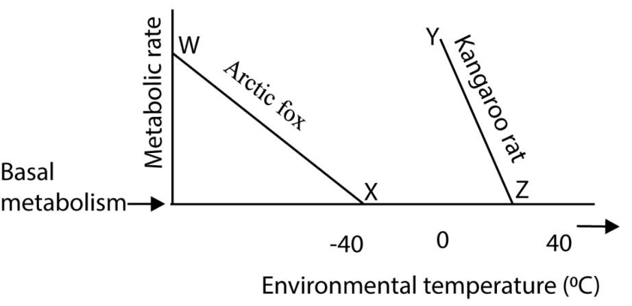
- What do points X and Z stand for? (1mark)
  - Lower critical point
- Give two differences in metabolic rates of the Kangaroo rat and the arctic fox in relation to environmental temperature. (2marks)
  - The critical temperature of arctic fox is lower than that of Kangaroo
  - Below the critical point metabolic rate in arctic fox raises slowly
- What do the differences you have stated (b)(ii) imply? (2marks) - Arctic fox has better insulation than kangaroo rat

- The figure shows the variation of metabolic rate with environmental temperature in a mammal

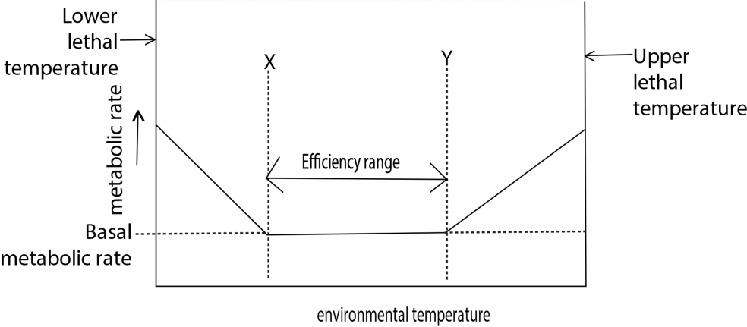

  - What do temperature X and Y represent? (01marks each)
    - X – lower critical temperature
    - Y – upper critical temperature

  - What does the efficiency range mean? (02marks)
- in efficient range the body is able to control its constant temperature by behavioural and physical means.

  - Explain the variation of metabolic rate with environmental temperature outside the efficient range. (05marks)

  - Below the lower critical temperature metabolic rate increase to generate heat to maintain the body temperature

  - Above the higher critical temperature metabolic rate increases due to increase the enzymatic activity.

  - The efficiency range is not fixed but differs from animal to animal. Giving a reason, state how point X would differ between animals living in cold environment and that living in a hot environment. (02marks)

- X is lower for animals living in cold environment because they have higher insulation i.e.
thick fur and big deposit of subcutaneous fats.
- Heat loss (-) and heat again (+) were monitored and recorded, of a naked human being at varying environmental temperatures. The heat losses and gain by the internal body environment body core), heat losses and gain by the skin surfaces as a result of radiation and convection and also heat losses as a result of evaporation, with varying environmental temperature, are shown in figure below:
Study the figure and answer the questions that follow

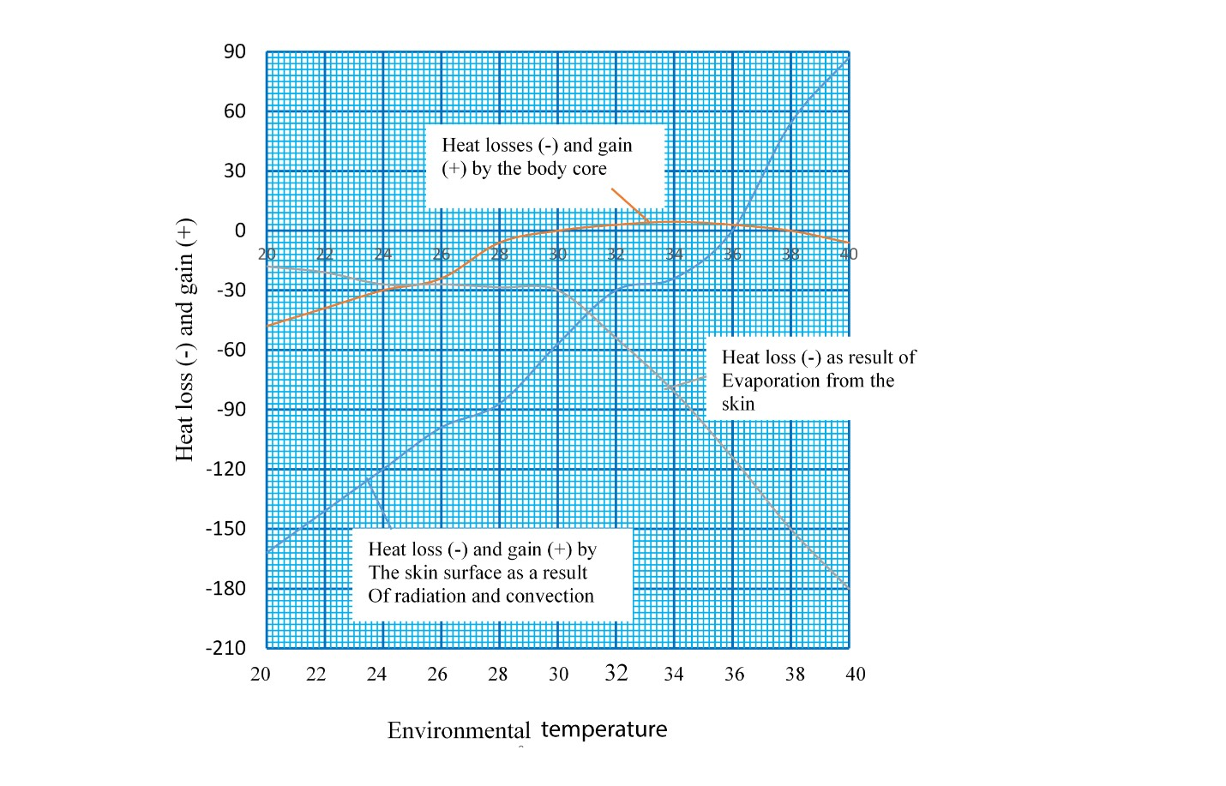
  - Describe the relationship between the heat loss and again by the skin surface as a result of radiation and convection and heat loss as a result as a result of evaporation from the skin. (4marks)

At 20⁰C, heat loss by radiation and convection is much higher (162 units) than that due to evaporation from the skin (18units)

Between 20-27⁰, heat loss by evaporation from the skin increases gradually while loss through radiation and convection decreases rapidly.

Between 27-28.8 ⁰C, loss through evaporation is constant while loss through radiation and convection continues to reduce.
Between 28.8 -31⁰C, evaporation loss begins to increase more rapidly to equal to the due to radiation and convection by 31⁰ C.

From 31 -40⁰C, loss through evaporation increases very rapidly while that through radiation and convection decreases more gradually to zero at 35.0⁰C and then the body starts gaining heat through radiation and convection rapidly up to 40⁰C.

- How does the relationship in (a) affect the losses and gain of heat from the body core (3marks)?
At 20⁰C, the body core is losing heat at a rate of 51units.
Heat loss decreases gradually from 20⁰C until it reaches zero at 30⁰C
From 30 -33⁰C, the body core gains heat gradually and then at a constant rate between 34⁰C and 37.4⁰C.
Between 37.4 -40⁰C, the body loses heat gradually.

- Explain the trend in heat losses and gain by the
(i) Skin surface as a result of radiation and convection (10marks)

At 20 ⁰C, the body is at a much higher temperature than surrounding and so the temperature gradient is high, favouring loss of heat from the body surface mainly by radiation convection.
As environment temperature increases, the temperature gradient reduces so that heat loss through radiation and convection reduces while that through evaporation increases gradually .
Between 32 -35.4⁰C, the temperature gradient is so small that heat loss through radiation and convection reduces more gradually until it reaches zero at 35.4⁰C.

Between 35.4 -40⁰C, now the temperature gradient reverses so that environment temperature becomes higher than body temperature. As a result, the body starts to gain heat by radiation and convection from the environment.
- Skin surface as a result of evaporation (08marks)

At 20⁰C, external temperature is very low compared to the normal human body temperature. As a result, the skin surface blood vessels constrict to reduces blood flow to the skin and also the rate of sweating is greatly reduced by the thermoregulatory Centre. As such, loss of heat by evaporation from the skin surface is low.
At the same time, the erector muscles and skin surface hairs are standing on end. This traps a layer of air close the surface, which on top of being insulator, also traps vapour close to the skin. This results in very low rate of evaporation from the skin surface is very low.
As temperature increases, between 20 -27⁰C, the vapour trapped in the hairs evaporates and also the rate of blood flow to the skin improves, sweat production increases and therefore heat loss by evaporation increases gradually.

- Body core (12marks)

Heat loss from body core occurs by a combination of radiation, convection, evaporation and conduction however, the body has regulatory mechanisms that resist subtle changes in core body temperature.
At 20⁰C, body is losing heat by a combination of evaporation, radiation and convection, though much of the heat is lost through radiation and convection.
  - To resist subtle drop in core body temperature, metabolic rate of the body core increase and the individual starts to shiver. These activates generate heat within the body core to make up for the losses from the body surface.
  - As a response to low core body temperature, the hypothalamus triggers a reduction in sweat production, reduction in blood flow to the skin surface and contraction of the erector pili muscles so that the surface hairs stand on end.
  - All these events reduce heat loss from the body core from the body core until is it zero at 30⁰C
As environment temperature comes close to the core body temperature remains constant for the range 34.8 – 37.4⁰C
Above 37.4⁰C, events are reversed in order to prevent subtle increases in core body temperature.
  - The erector muscles relax so that the surface hairs lie flat on the skin surface, trapping no air between them.
  - Blood flow to the skin surface is increased and
  - Sweating increases so that heat loss from the body surface by evaporation increases greatly.
  - Metabolic heat production and shivering stop.
The end result is that the body core starts to lose heat to the environment from 38-40ºC in order to give off the excess heat and maintain a constant body temperature

(d) What is the importance of maintaining body temperature in animals (3marks)

Temperature must be maintained at a value optimum for the action of enzymes upon which the organized functioning of cells depends. At higher temperature Enzymes being protein in nature are denatured while at low temperature they are inactive.
17. (a) Mammals in cold habitats usually have a large body size as a result of extra fat deposits under the skin.
- The big size reduces the surface area to volume ratio and therefore reduces the rate of heat loss from their bodies across the surfaces.
- The fat deposits under the skin insulates and prevents heat loss to the environment.
(b) Strategies of the camel to overcome heat stress include:
- Possession of tissues which are tolerant to wide ranges of temperature.
- The camel stores heat in its tissues during day when temperature are very high and then loses it during the night by radiation, conduction and convection and not evaporation, when temperatures are low
- During the day, the camel behaves like an ectothermic animals, allowing its temperature to get close to those of the environment. This reduces the temperature difference between the hot air of the desert and its body so that the rate of heat gain from the surrounding is reduced.
- The fur that the camels skin acts as an efficient insulating barrier by reducing heat gain and loss by convection and conduction.

